Phase 1: Problem Understanding & Industry Analysis

PROJECT : Consumer goods distributor partner portal

1. Introduction
Phase 1 of the Salesforce Consumer Goods Partner Portal Project focuses on understanding the business problem, analyzing the industry, and defining the functional and technical requirements. This phase ensures that all subsequent development and configuration work aligns with real-world business processes and stakeholder expectations.
The project goal is to build a portal where distributors can place orders, track inventory, and interact with company-managed products efficiently.

2. Requirement Gathering

2.1 Functional Requirements
Feature | Description
Distributor Order Placement | Distributors log in and create orders by selecting products and entering quantities.
Inventory Validation | Check product availability before confirming the order.
Line Item Management | Each order can include multiple products (line items).
Partner Management | Admins manage distributor profiles, contacts, and permissions.
Reporting | Dashboards for orders, inventory, and partner performance.
Notifications | Email alerts for order confirmations, approvals, or low stock.

2.2 Non-Functional Requirements
Requirement | Description
Performance | System must handle multiple concurrent orders.
Security | Role-based access and sharing rules to protect sensitive data.
Scalability | Ability to add new distributors, products, and integrations.
Usability | Intuitive interface for distributors and admins.

2.3 Tools Used
- Meetings with stakeholders to capture business requirements.
- Documentation in spreadsheets, word docs, and requirement tracking sheets.
- References from industry standards and Salesforce AppExchange solutions.

3. Stakeholder Analysis
Identifying stakeholders ensures the portal meets the needs of end users and business managers.
Stakeholder | Role | Permissions
Distributor | Place and track orders | Create/Read orders, Read products & inventory
Admin | Manage products, inventory, and orders | Full CRUD access
Project Mentor | Oversight and review | Read-only access to dashboards and reports

4. Business Process Mapping

4.1 Order Process Flow
- Distributor logs in and selects products.
- System checks inventory for availability.
- Partner_Order__c record is created.
- Each product generates an Order_Line_Item__c record.
- Inventory__c is updated automatically.
- Notifications sent to distributor and admin.
- Reports reflect the new order and stock changes.
Distributor → Order → Inventory Update → Notifications.

4.2 Automation Points
- Auto-update inventory when orders are placed.
- Validation rules to prevent over-ordering.
- Email notifications for order confirmations and low stock alerts.

5. Industry-Specific Use Case Analysis

5.1 Context
The consumer goods industry requires fast order cycles and accurate inventory tracking. Portals must support:
- Multiple simultaneous orders
- Real-time inventory updates
- Automated reporting for sales and stock

5.2 Benchmarking
- Reviewed Salesforce AppExchange solutions for partner portals.
- Identified best practices for object design, process automation, and API integration.

6. Challenges Identified
- Ensuring real-time inventory updates without exceeding Salesforce governor limits.
- Designing REST APIs for external order placement.
- Managing complex object relationships: Product → Inventory → Line Item → Partner Order.

7. Outcome of Phase 1
- Requirements documented and approved.
- Stakeholders and access levels defined.
- Business process mapped with automation points identified.
- Blueprint for Salesforce objects, fields, and relationships prepared for Phase 3.

Phase 2: Org Setup & Configuration

PROJECT : Consumer goods distributor partner portal

1. Introduction
Phase 2 focuses on setting up the Salesforce environment and configuring the org to meet project requirements. Proper org setup ensures security, proper access, and a solid foundation for further development and automation.
Objectives:
- Set up Salesforce Developer Org and Sandboxes.
- Configure company profile, fiscal year, business hours, and holidays.
- Set up users, roles, profiles, permission sets, and access policies.
- Understand deployment basics using Salesforce CLI and VS Code.

2. Salesforce Edition & Company Profile

2.1 Salesforce Edition
- Chose Developer Edition for learning and project development.
- Enabled Lightning Experience for modern UI.
Screenshot Suggestion: Salesforce Setup → Company Settings → Company Information.
Take screenshot: The page showing Organization Name, Salesforce Edition, Instance.

2.2 Company Settings
- Company Profile: Added company details like name, address, primary contact, currency, default locale.
- Business Hours & Holidays: Defined standard business hours and holidays for workflow and approval processes.
- Fiscal Year Settings: Configured standard fiscal year to align with reporting requirements.
- 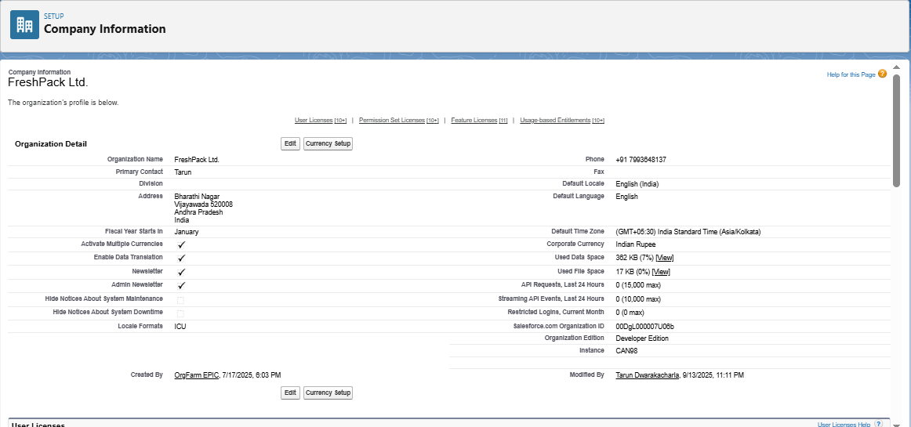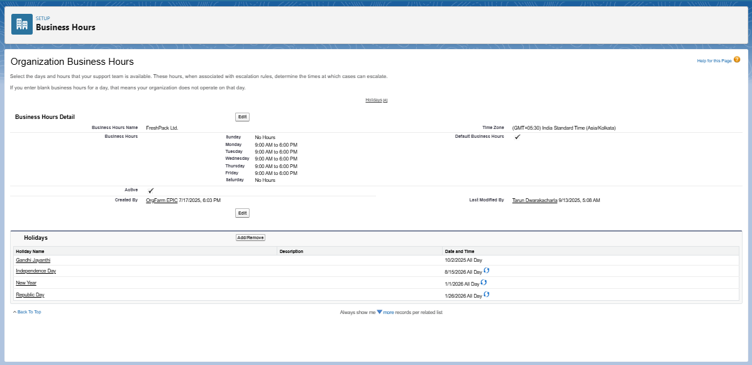

3. User Setup & Access Management

3.1 Users & Licenses
- Created test users for Admin, Distributor, and Partner roles.
- Assigned appropriate Salesforce licenses and feature licenses.

3.2 Profiles
- Defined profiles to control access:
  - Admin Profile: Full CRUD permissions on all objects.
  - Distributor Profile: Limited access to Partner Order, Product, and Inventory objects.
- Configured tab visibility and object permissions.
.

3.3 Roles
- Created roles to define the hierarchy:
  - Admin → Distributor → Partner Manager.
- Roles control record-level access in combination with sharing rules.

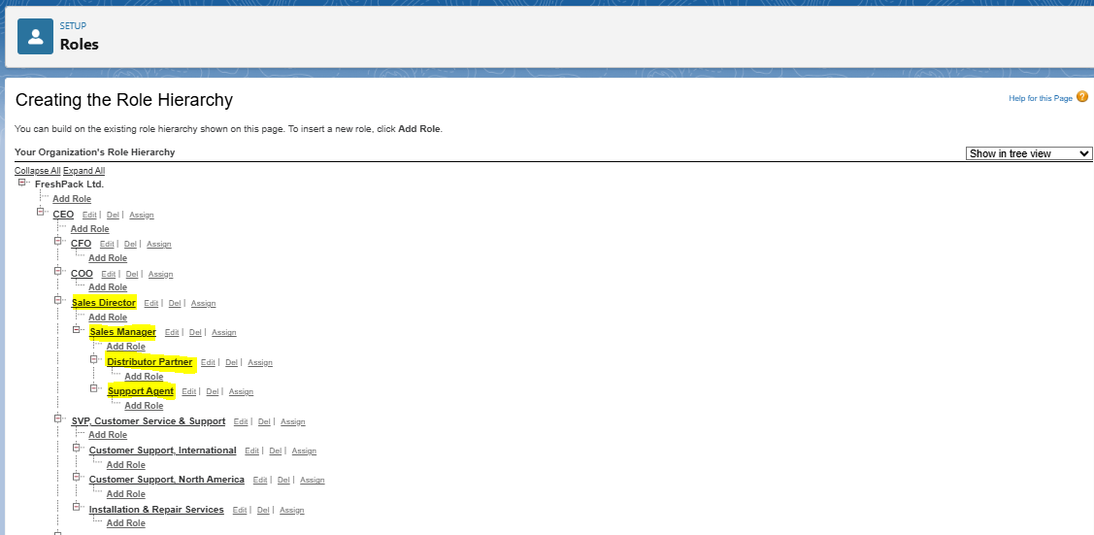3.4 Permission Sets
- Created permission sets for additional access beyond profiles, e.g., API access, custom object access.
- Assigned permission sets to users as required.

4. Organization-Wide Defaults & Sharing Rules
- Configured OWD (Organization-Wide Defaults) to ensure proper record-level security:
  - Partner_Order__c: Private
  - Inventory__c: Public Read Only
- Created Sharing Rules to share Partner Orders with Admins and Managers automatically.
Setup → Security → Sharing Settings → OWD Table.

5. Login & Security Policies
- Configured Login Access Policies to allow admins to log in as users for support and troubleshooting.
- Configured Login IP Ranges and Session Settings for security compliance.
Setup → Security → Login Access Policies.

6. Developer Org Setup & Sandbox Usage

6.1 Dev Org Setup
- Created a Developer Org for the project.
- Connected VS Code with Salesforce CLI (SFDX).
VS Code Setup Steps:
- Installed Salesforce CLI.
- Installed Salesforce Extension Pack in VS Code.
- Authorized the org:
- sf login org --alias DevOrg
- Created project folder structure:
- sfdx force:project:create -n ConsumerGoodsPartner
VS Code → Salesforce CLI Terminal showing successful login.

6.2 Sandbox Usage
- Created Partial Copy Sandbox for testing deployment without affecting production data.
- Configured sandbox refresh schedule.
Setup → Sandboxes → Sandbox List.

7. Deployment Basics
- Learned metadata deployment using Salesforce CLI:
  - Deploy Apex classes, objects, and flows from VS Code:
  - sf deploy metadata --metadata ApexClass --target-org DevOrg --wait 10
- Checked deployment status and logs to ensure successful code migration.
Screenshot Suggestion: VS Code terminal showing deployment success.

8. Outcome of Phase 2
- Salesforce org fully configured with company profile, fiscal year, business hours, and holidays.
- Users, profiles, roles, and permission sets configured for project security and access control.
- Developer org connected to VS Code for easy code and metadata deployment.
- OWD and sharing rules established for record-level security.

Phase 3: Data Modeling & Relationships

1. Introduction
Phase 3 focuses on designing the data architecture of the Salesforce project. Proper data modeling ensures accurate tracking of business processes, seamless integration with automation, and correct reporting.
Objectives:
- Create standard and custom objects.
- Define fields, relationships, record types, and page layouts.
- Configure lookup, master-detail, and junction objects.
- Design data model for Partner Orders, Products, Inventory, and Order Line Items.

2. Standard & Custom Objects

2.1 Standard Objects
- Leveraged Salesforce standard objects for basic functionality:
  - Account – Used for Distributors and Partners.
  - Contact – For partner representatives.

2.2 Custom Objects
- Created custom objects for project-specific requirements:
  - Product__c – Stores product catalog details.
  - Inventory__c – Tracks available inventory per product.
  - Partner_Order__c – Captures partner orders.
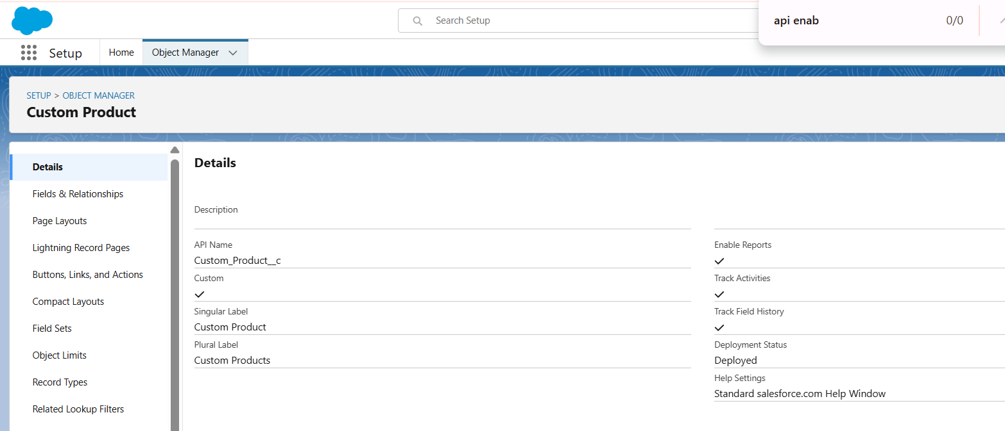
  - Order_Line_Item__c – Line items for each order.

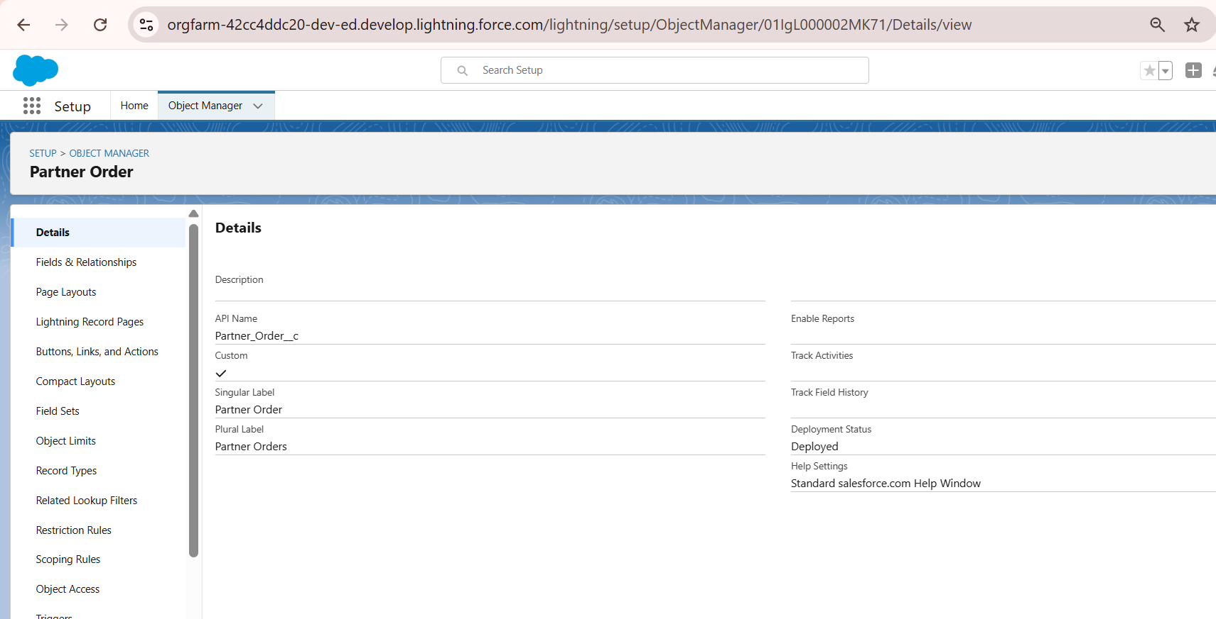
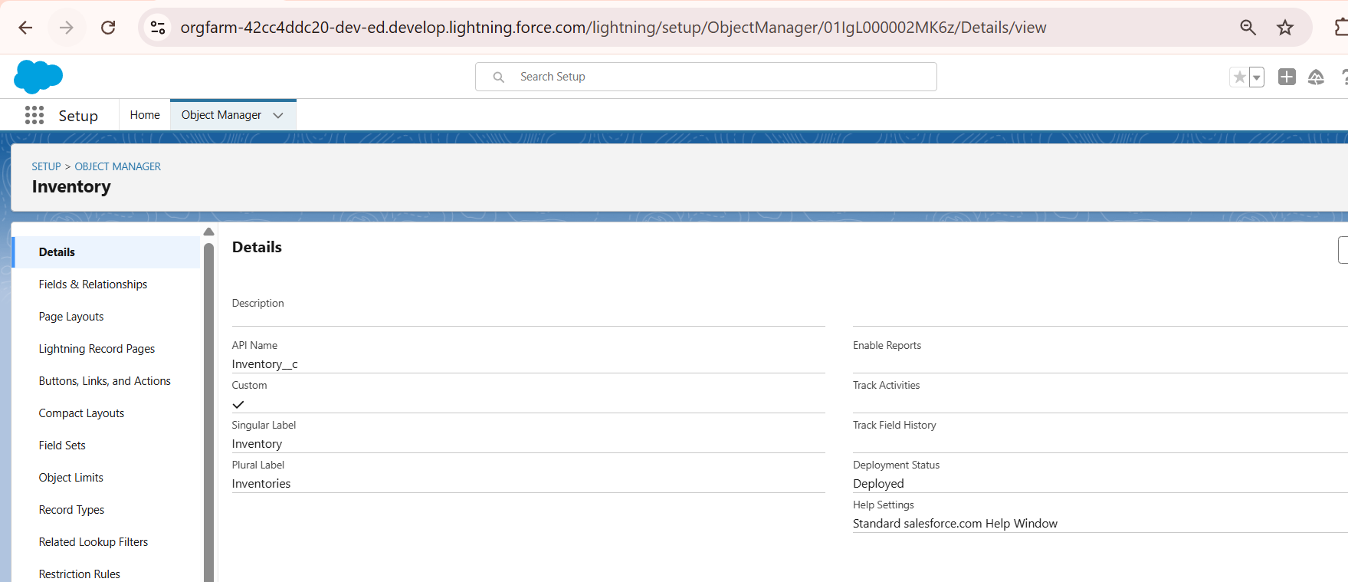
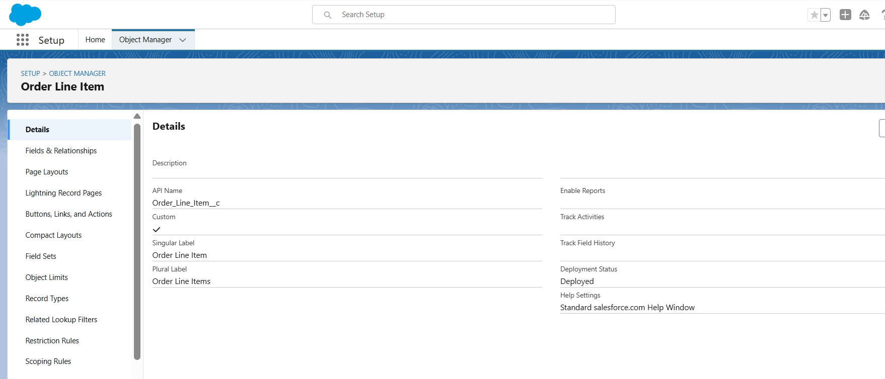

3. Custom Fields
- Created fields for each custom object with appropriate data types:
Object | Field | Type | Description
Product__c | Name | Text | Product name
Product__c | SKU__c | Text | Product SKU code
Product__c | Price__c | Currency | Product price
Inventory__c | Product__c | Lookup(Product__c) | Product associated with inventory
Inventory__c | QuantityAvailable__c | Number | Available stock
Partner_Order__c | Distributor__c | Lookup(Account) | Distributor placing the order
Partner_Order__c | Total_Amount__c | Currency | Total order value
Order_Line_Item__c | Partner_Order__c | Master-Detail(Partner_Order__c) | Parent order
Order_Line_Item__c | Product__c | Lookup(Product__c) | Product for line item
Order_Line_Item__c | Quantity__c | Number | Quantity ordered
Order_Line_Item__c | UnitPrice__c | Currency | Price per unit
- Object Manager → Product__c → Fields & Relationships.
- Show newly created fields with data types.
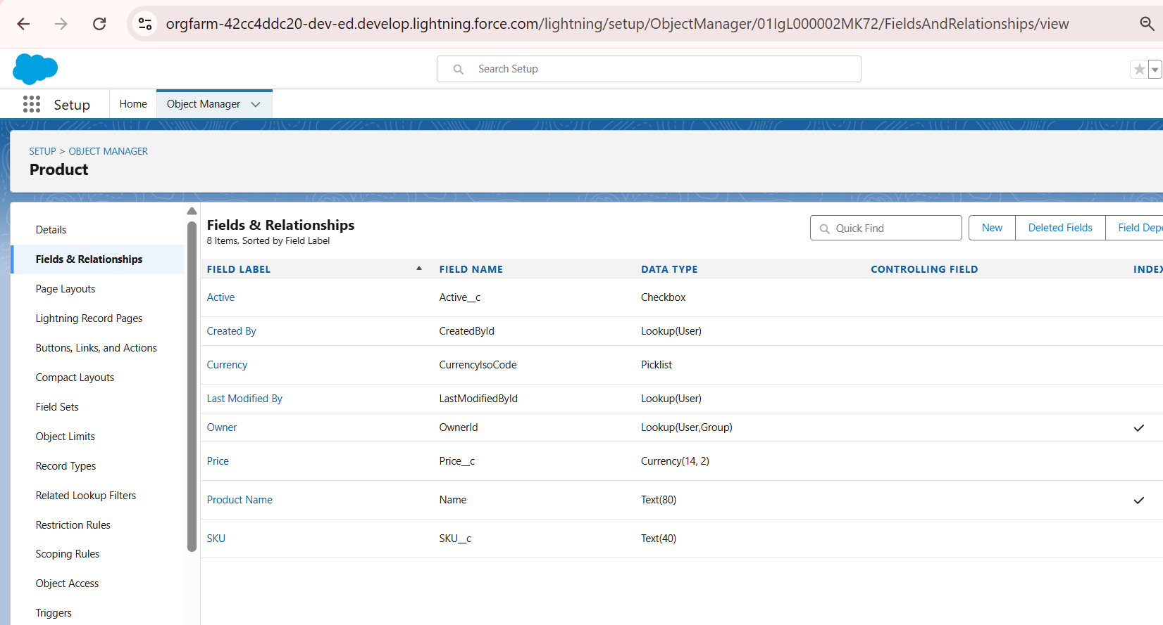

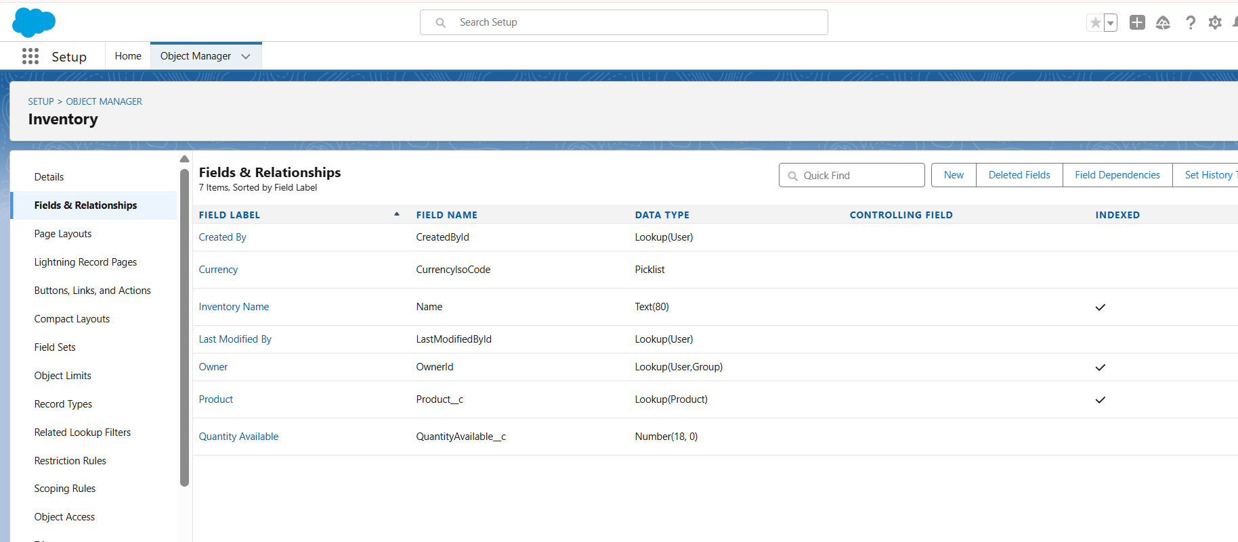

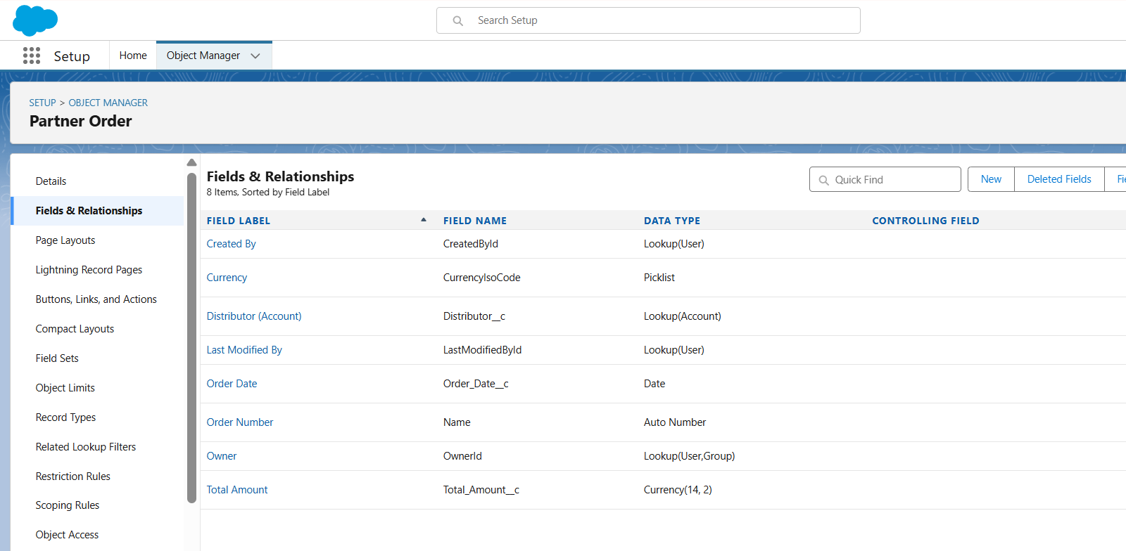
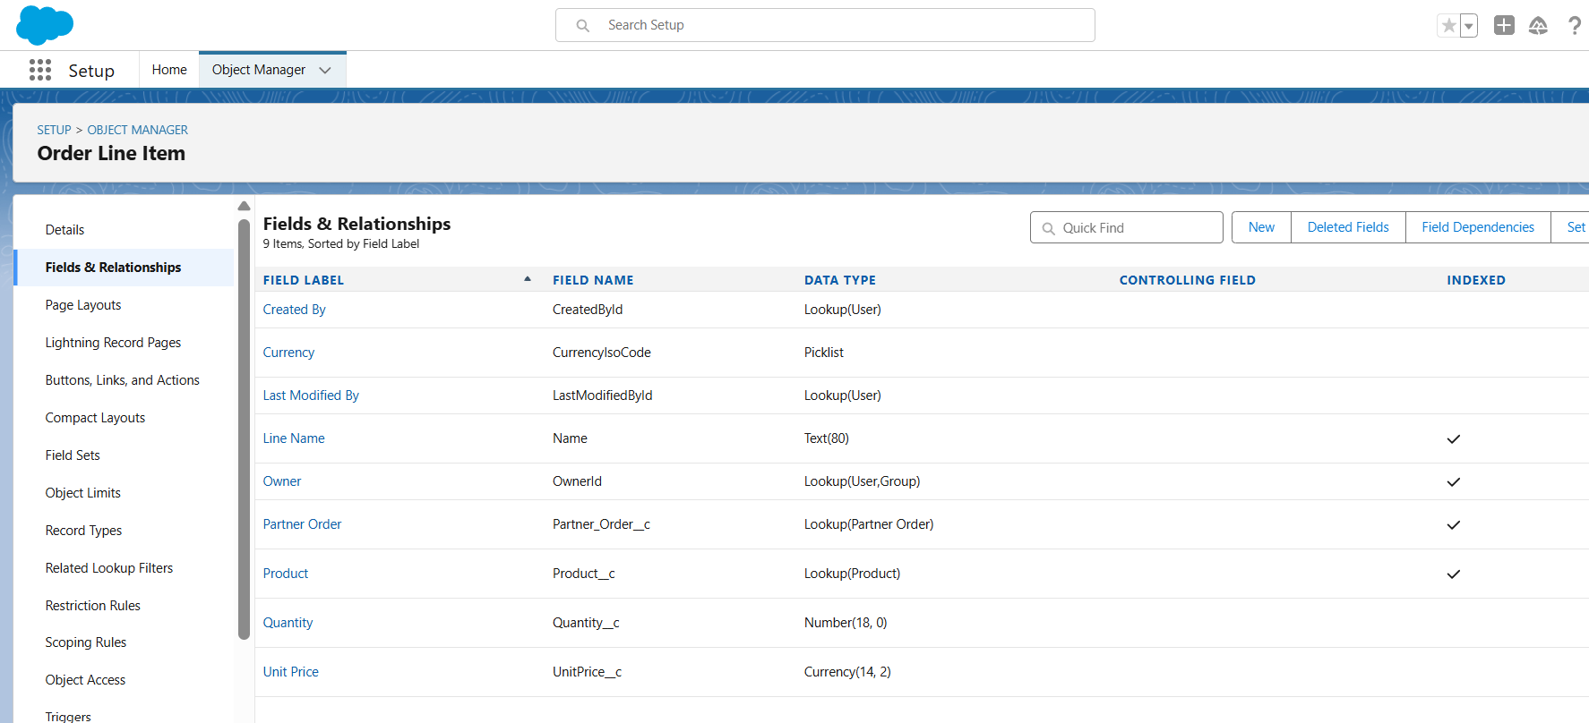

4. Record Types & Page Layouts

4.1 Record Types
- Created record types to differentiate between Distributor Orders and Partner Orders.
- Assigned appropriate page layouts and picklist values for each record type.

4.2 Page Layouts
- Customized layouts for each object to improve user experience:
  - Moved critical fields to top section.
  - Added related lists (Order Line Items under Partner Orders).

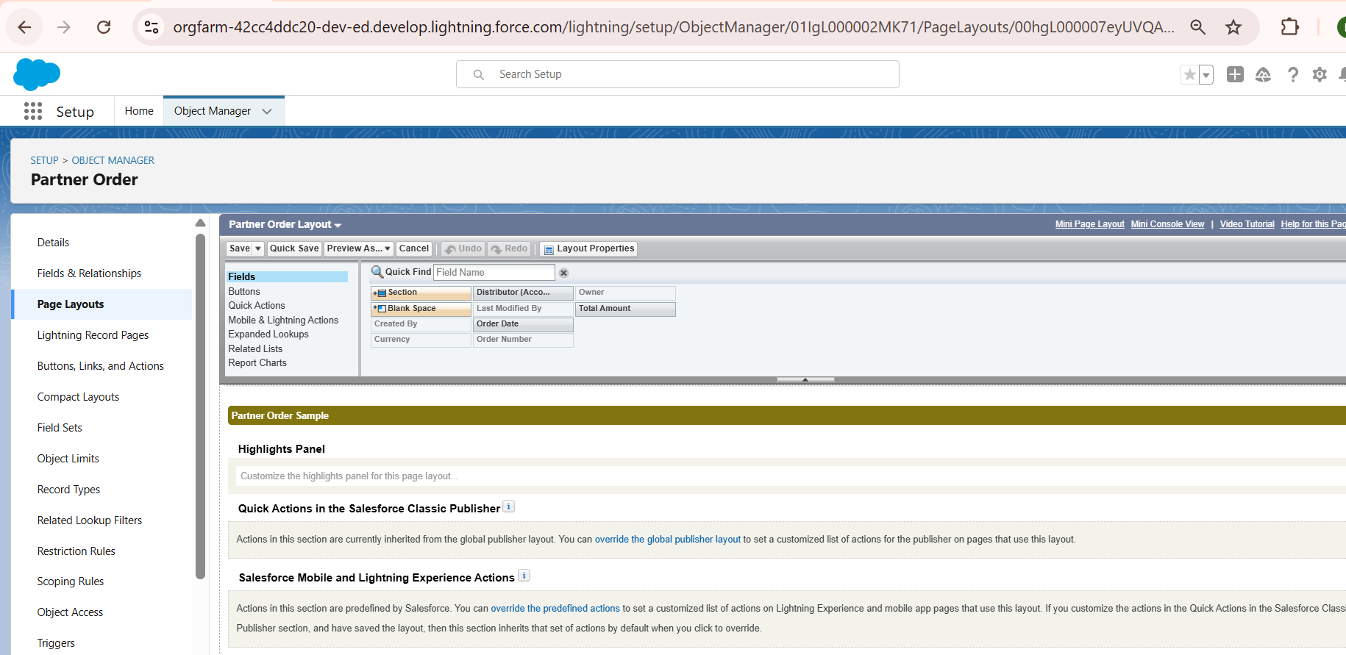4.3 Compact Layouts
- Designed compact layouts for record previews in Lightning Experience.
- Displayed key fields such as Distributor Name, Total Amount, and Order Date.

5. Relationships

5.1 Lookup vs Master-Detail
- Lookup Relationship: Inventory → Product (optional relationship, records can exist independently).
- Master-Detail Relationship: Order_Line_Item__c → Partner_Order__c (child cannot exist without parent).
- Junction Objects: N/A for this project but can be used for many-to-many relationships.

5.2 Schema Builder
- Used Schema Builder to visualize object relationships and ensure proper cardinality:
  - Partner_Order__c → Order_Line_Item__c (1:N)
  - Product__c → Inventory__c (1:1)
  - Product__c → Order_Line_Item__c (1:N)

6. External Objects (Optional)
- Explored external objects for connecting external data sources if required in future integrations.
- Configured Salesforce Connect to link with external inventory systems.

7. Outcome of Phase 3
- Custom objects for Products, Inventory, Partner Orders, and Order Line Items created.
- Fields, relationships, and record types designed to accurately capture business processes.
- Page layouts and compact layouts enhanced user interface for Salesforce Lightning Experience.
- Schema Builder diagram validated object relationships and cardinality.
Screenshot Suggestions for Documentation:
- Object Manager → Custom Objects list.
- Fields & Relationships → Product__c or Inventory__c with field types.
- Record Types page → Distributor vs Partner Orders.
- Page Layout Editor → Partner_Order__c layout.
- Schema Builder → Full data model diagram.
- Optional: External Objects setup if connected.

Phase 4: Process Automation (Admin)
In this phase, the focus was on automating business processes without requiring Apex code. The main requirement in our project was to automatically adjust inventory quantities whenever a new Partner Order was placed.

4.1 Record-Triggered Flow for Inventory Update
Objective:
Whenever a new Partner Order record is created, the system should automatically subtract the ordered quantity from the available inventory of the selected product.
Steps Implemented:
- Navigate to Flows
  - Go to Setup → Quick Find Box → search for Flows → click New Flow.
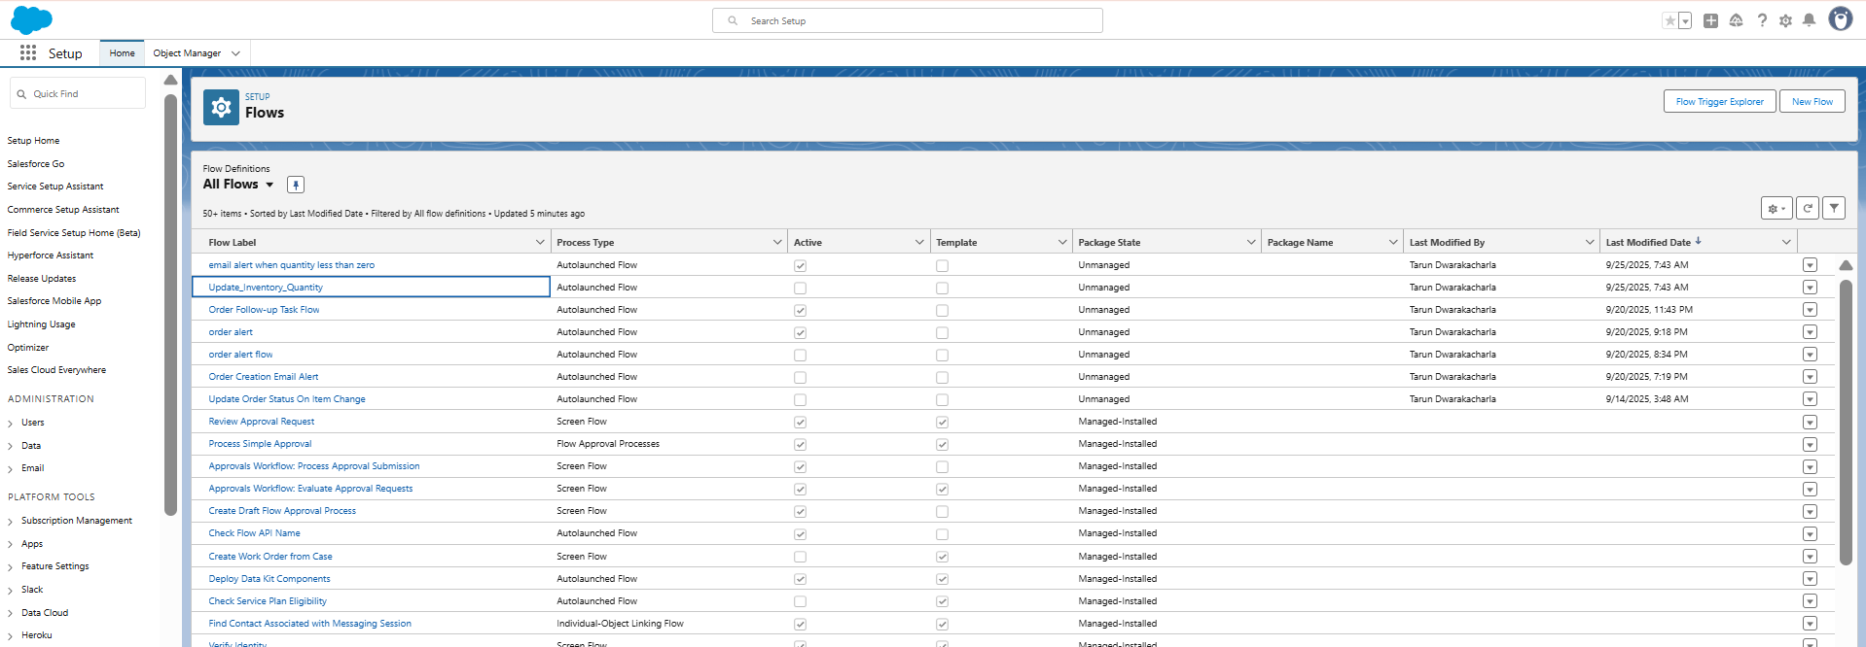
- Choose Flow Type
  - Select Record-Triggered Flow.
  - Object: PartnerOrder__c
  - Trigger: When a record is created.
  - Condition: None (runs for every new Partner Order).
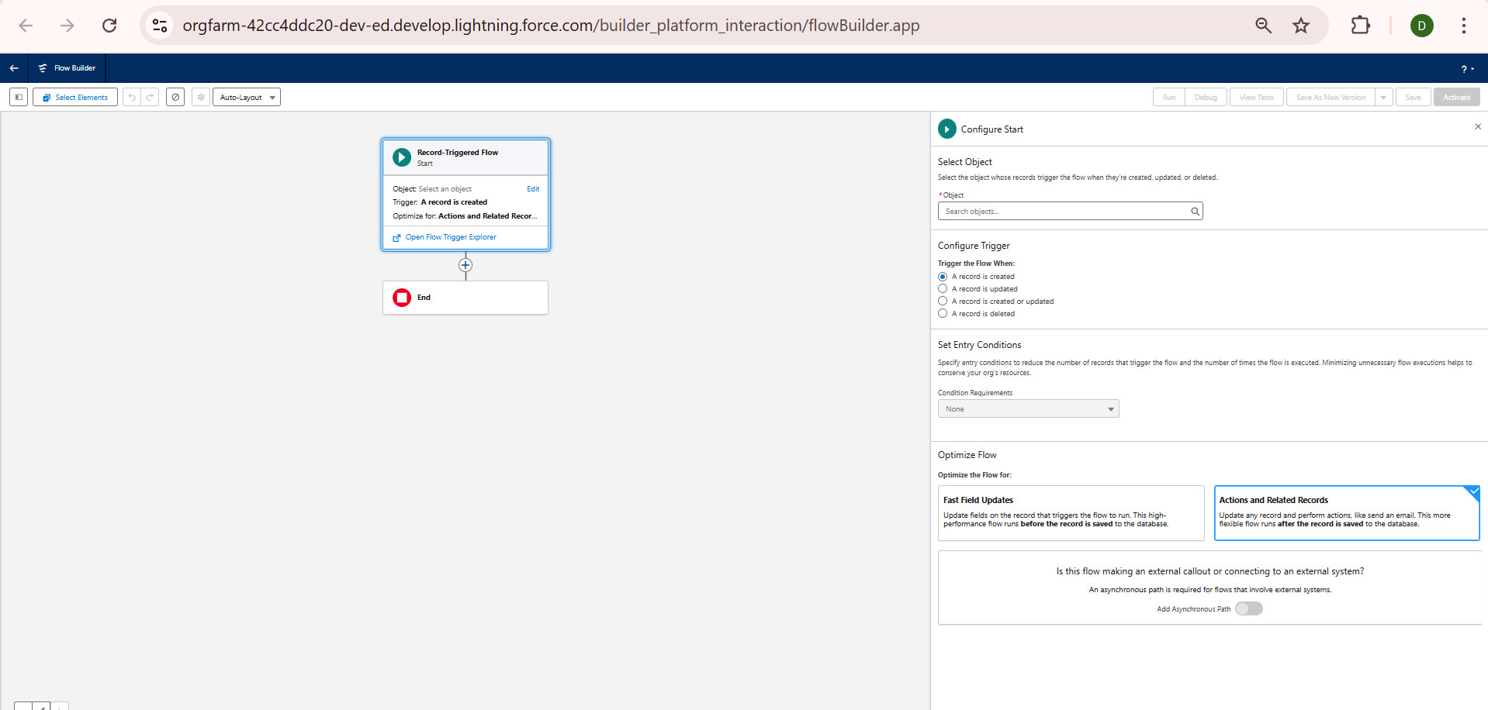
- Get Related Inventory Record
  - Add a Get Records element.
  - Object: Inventory__c
  - Condition: Product__c = {!$Record.Product__c}
  - Store the first record found.
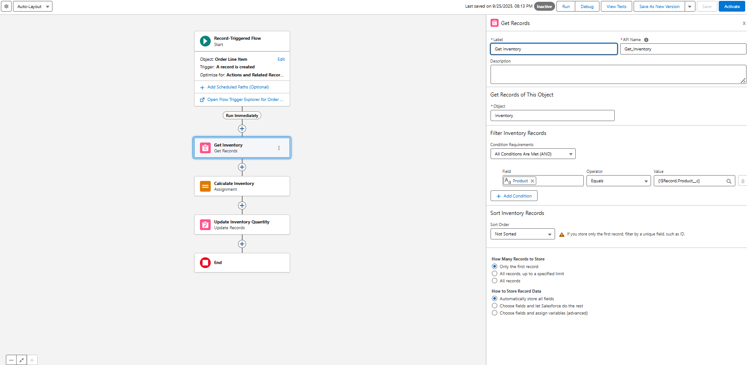
- Update Inventory Quantity
  - Add an Update Records element.
  - Record to Update: Inventory record from Get Records.
  - Field:
    - QuantityAvailable__c = {!Get_Inventory.QuantityAvailable__c} - {!$Record.Quantity__c}
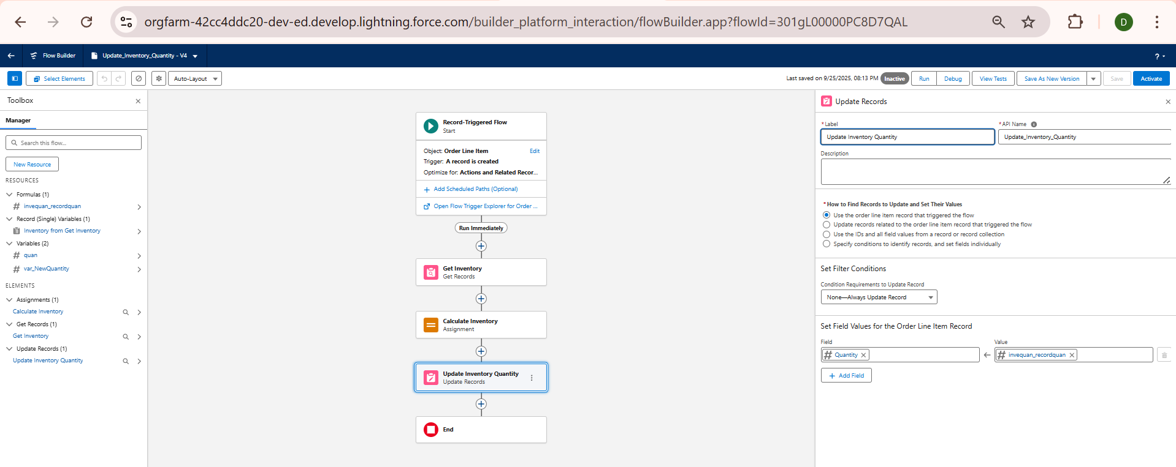
- Save and Activate Flow
  - Save the flow with the name: Update Inventory Quantity on Partner Order.
  - Activate it.

4.2 Testing the Flow
- Go to the Partner Order Page.
- Create a new Partner Order by selecting a Product and entering a Quantity.
- After submitting the order:
  - Navigate to the related Inventory__c record.
  - Confirm that the QuantityAvailable__c has been reduced by the ordered amount.
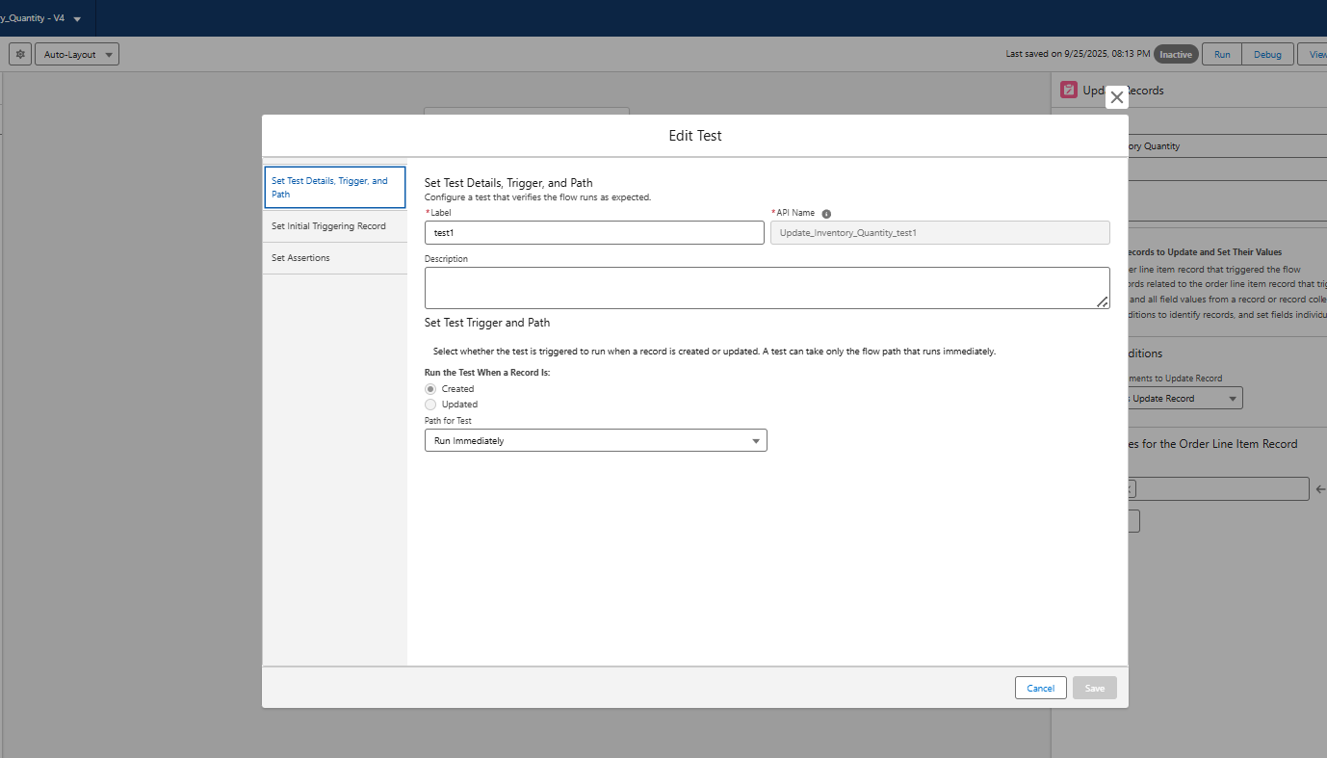
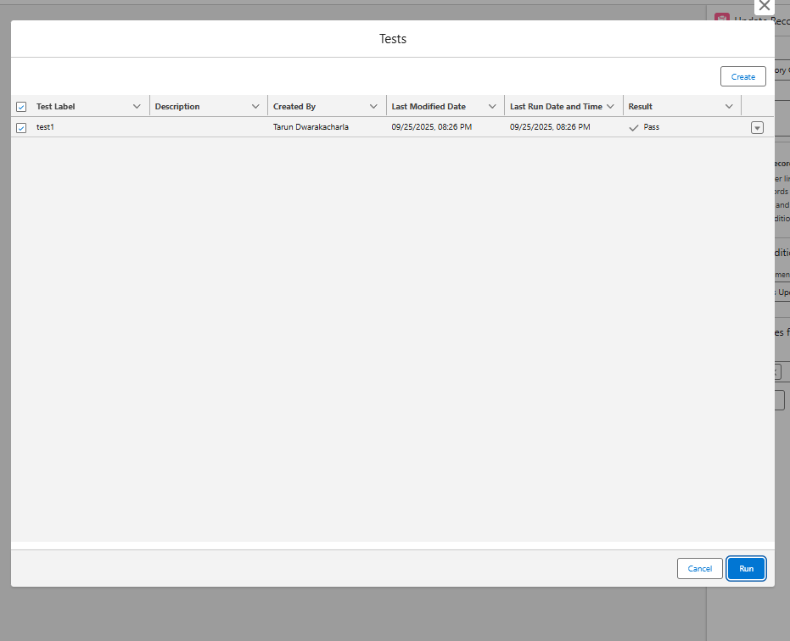

Achieved Outcome
- Inventory is now automatically updated whenever a Partner Order is created.
- No manual adjustments are required, reducing the chances of stock mismatches.

2. Validation Rule on Partner Order Quantity
Objective: Prevent users from entering invalid order quantities (e.g., negative or zero).
Steps:
- Go to Setup → Object Manager → PartnerOrder__c → Validation Rules.
- Click New Rule.
- Rule Name: Validate_Quantity
- Formula:
- Quantity__c <= 0
- Error Message: "Quantity must be greater than zero."
- Error Location: Field → Quantity__c.
- Save & Activate.
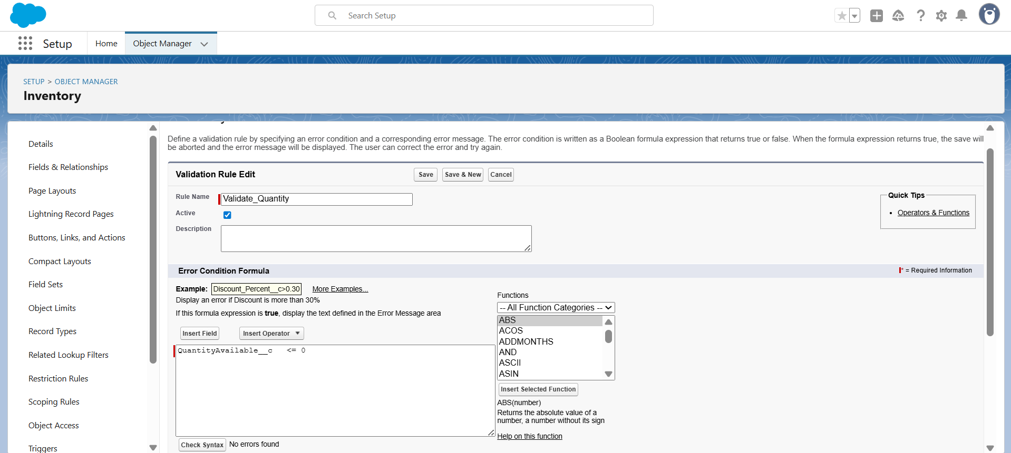
✅ Result: Users cannot save orders with zero or negative quantity.

🔹 2. Email Alert on Low Inventory
Objective: Notify an Admin when Inventory goes below a certain threshold (say 10 units).
Steps:
- Go to Setup → Flow.
- Create a Record-Triggered Flow on Inventory__c.
- Trigger: When a record is updated.
- Condition:
  - QuantityAvailable__c < 10.
- Action: Add Send Email.
  - Recipient: Admin Email (you can hardcode your email ID for testing).
  - Subject: "Low Inventory Alert"
  - Body: "The product {!$Record.Product__c} has low stock: {!$Record.QuantityAvailable__c} units left."
- Save & Activate.
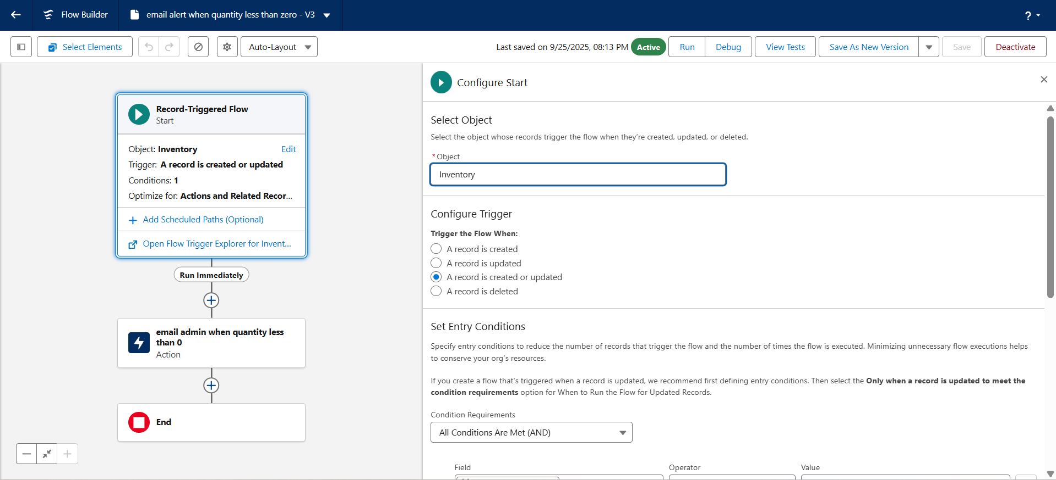

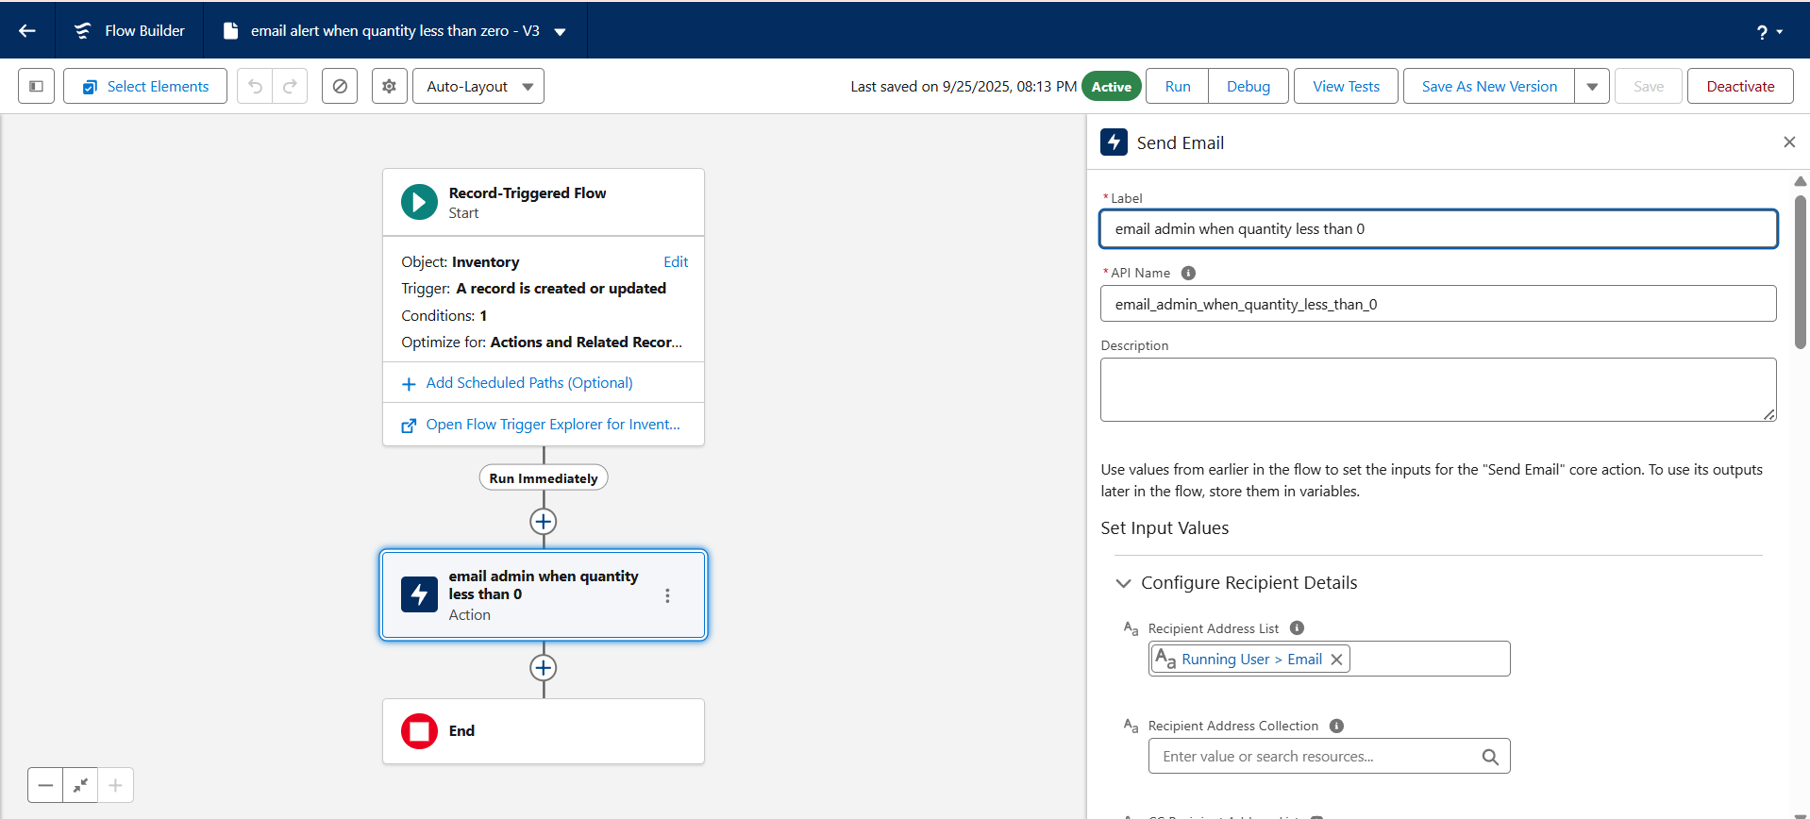

Testing the flow:
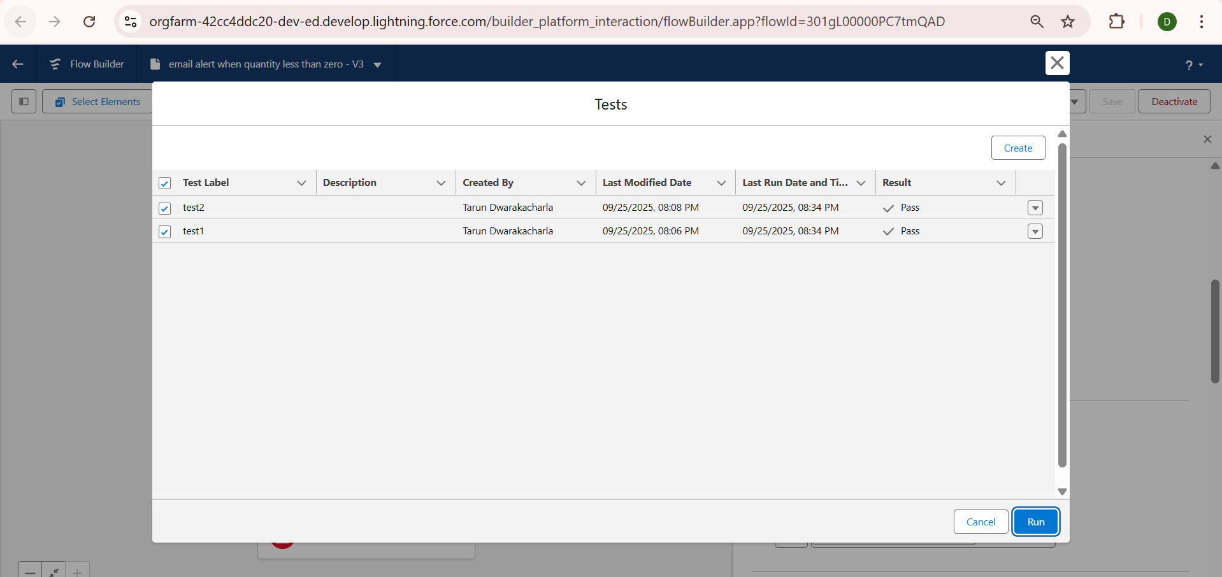

Phase 5: Apex Programming (Developer)

1. Introduction
Phase 5 focuses on extending Salesforce functionality using Apex code to implement complex business logic, automate processes, and handle integration scenarios.
Objectives:
- Develop Apex classes and triggers to process Partner Orders, Products, and Inventory.
- Handle bulk operations, asynchronous processing, and exceptions.
- Create test data and ensure proper coverage with Test Classes.
- Enable REST API endpoints for external systems.

2. Apex Classes
The following Apex classes were developed in the project:
Class Name | Purpose
OrderService | Core logic for creating and managing orders within Salesforce.
ProductService | Handles product-related operations such as price updates.
PartnerOrderService | Exposes a REST API endpoint for partners to create orders externally.
PartnerProductService | Provides product and inventory data to external systems via REST.
Key highlights:
- PartnerOrderService exposes /partner/v1/orders REST endpoint using @RestResource.
- Accepts JSON payloads containing distributorId and line items.
- Validates inventory, calculates totals, creates Partner_Order__c and Order_Line_Item__c records.
- Updates inventory quantities after successful order creation.
- Handles invalid payloads and returns appropriate HTTP status codes (400, 201).
Screenshot Suggestion: VS Code → Explorer → force-app/main/default/classes → Highlight all Apex classes.
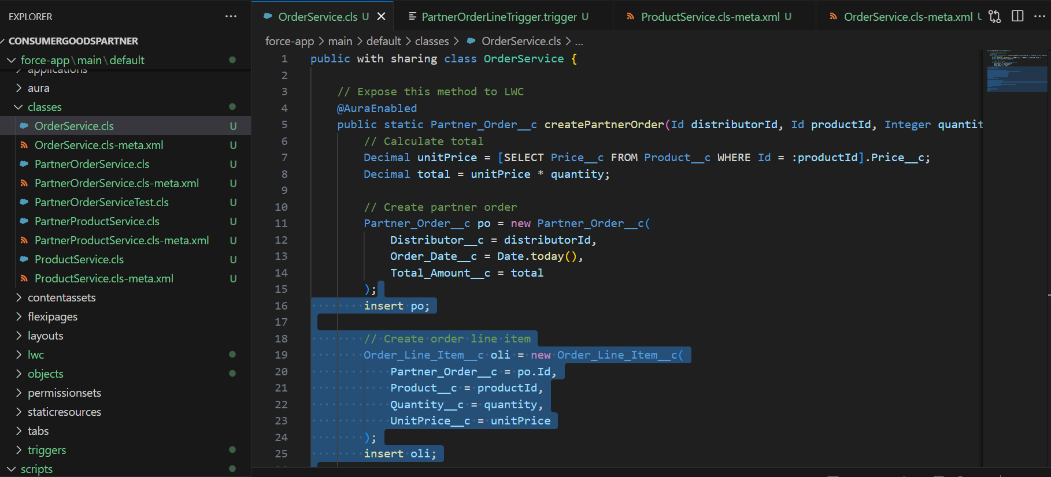
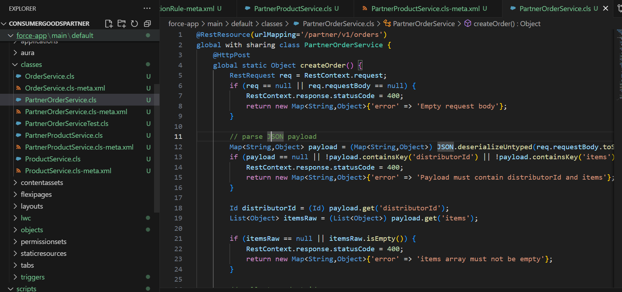
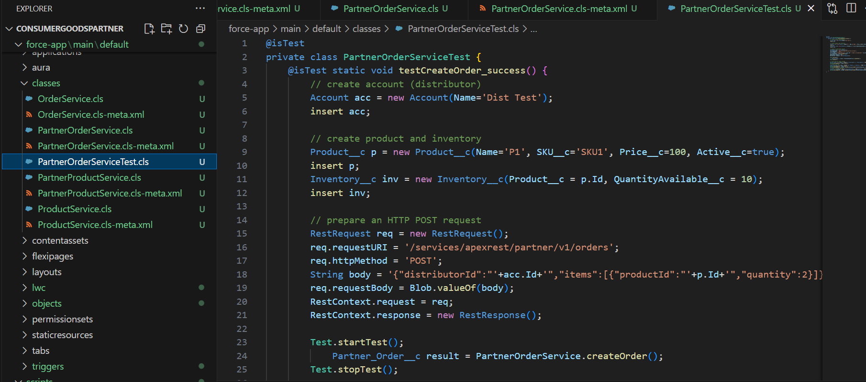
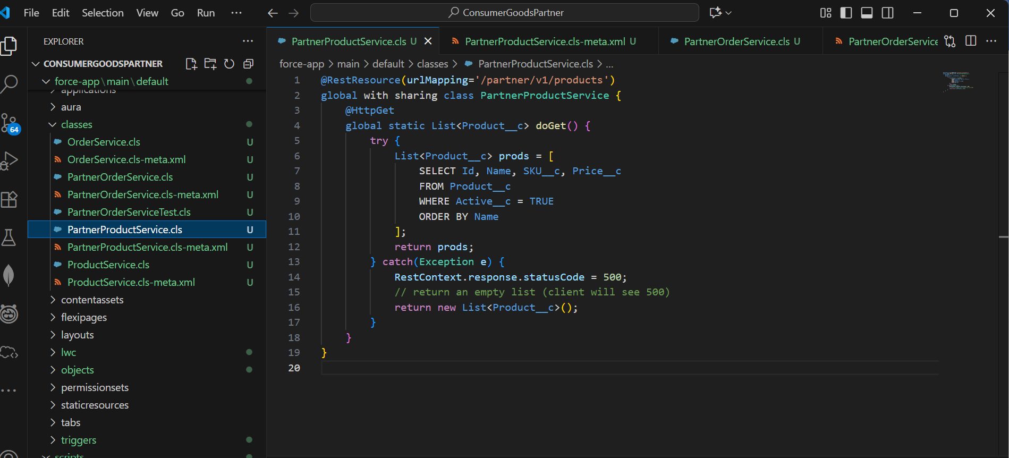
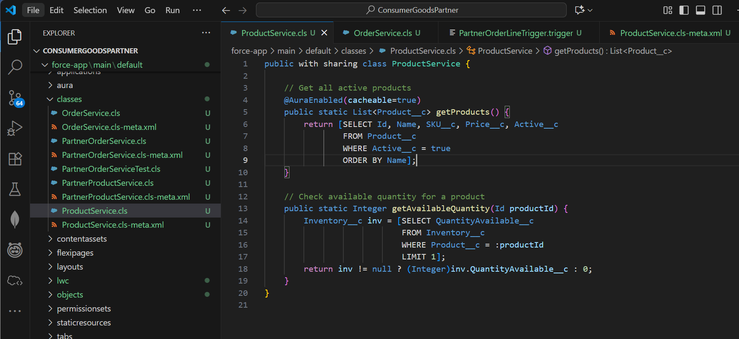

3. REST API Endpoint Example
Endpoint URL:
https://<your-dev-org>.lightning.force.com/services/apexrest/partner/v1/orders
Request JSON body:
{
"distributorId": "001gL00000P8auLQAR",
"items": [
{
"productId": "a07gL00000EiBURQA3",
"quantity": 5
}
]
}
- External systems can POST this payload to create partner orders automatically.
- Headers required:
  - Authorization: Bearer <ACCESS_TOKEN>
  - Content-Type: application/json

4. Apex Triggers
Order-Line Item Processing:
- Triggers were created to update inventory when a new order line item is inserted.
- Example: On insert of Order_Line_Item__c, the corresponding Inventory__c.QuantityAvailable__c is reduced.
- Handles bulk operations to comply with Salesforce governor limits.
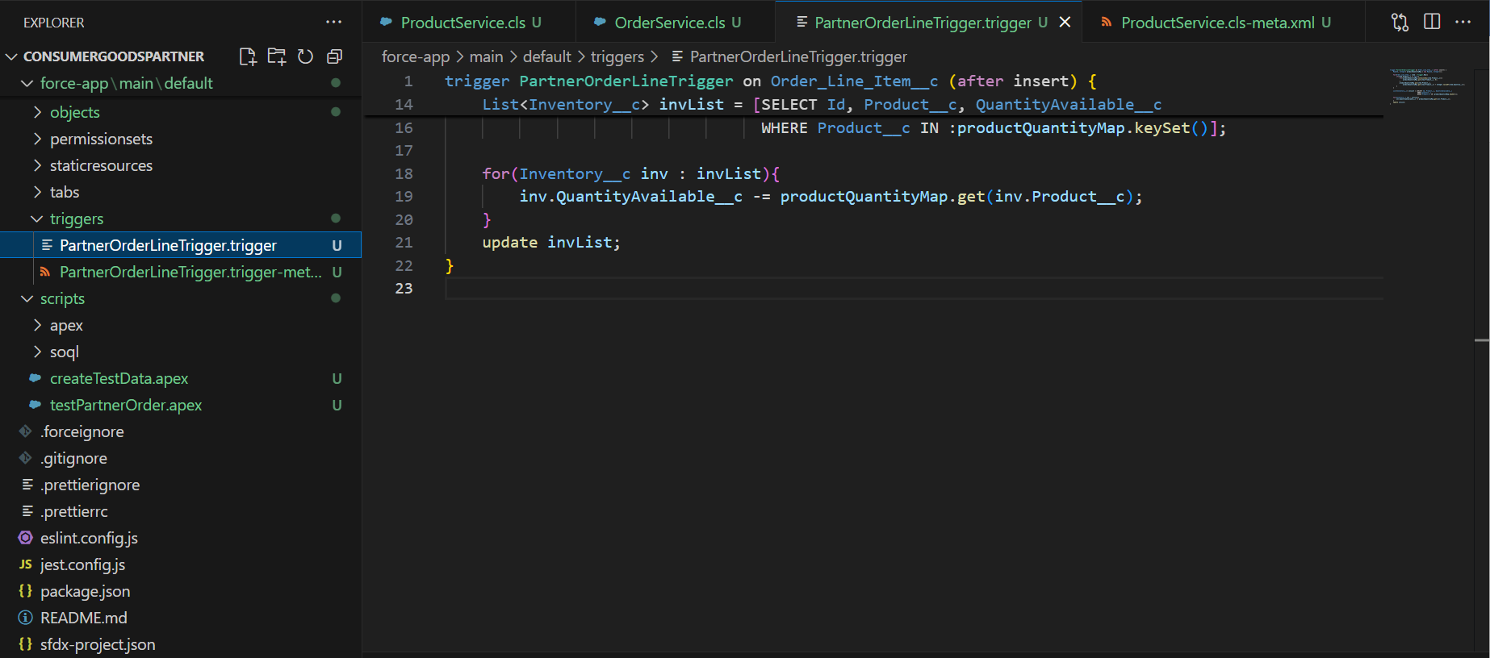

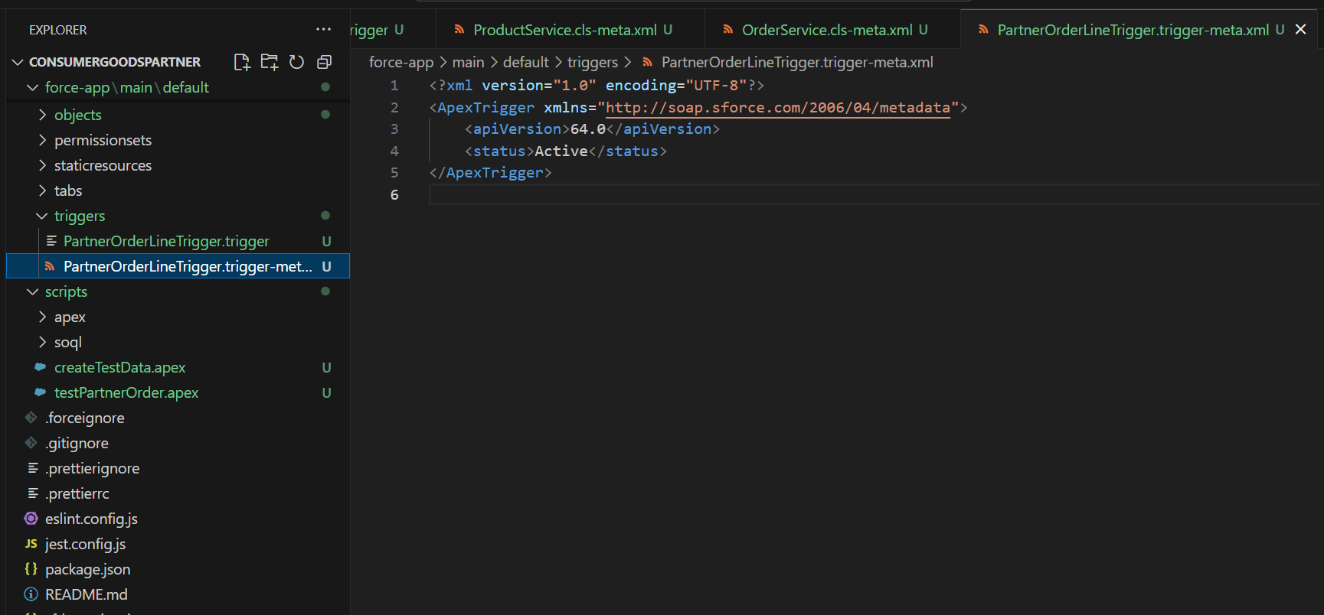

5. Test Data Creation
- Created anonymous Apex scripts to generate sample data for testing:
  - Distributor Account
  - Product__c records
  - Inventory__c records
Example Anonymous Apex Script:
Account a = new Account(Name='Distributor Test');
insert a;

Product__c p = new Product__c(Name='API Product 1', SKU__c='API-SKU-1', Price__c=150, Active__c=true);
insert p;

Inventory__c inv = new Inventory__c(Product__c = p.Id, QuantityAvailable__c = 20);
insert inv;

System.debug('DIST:' + a.Id + ' PROD:' + p.Id);
Screenshot Suggestion: VS Code → scripts folder → createTestData.apex.
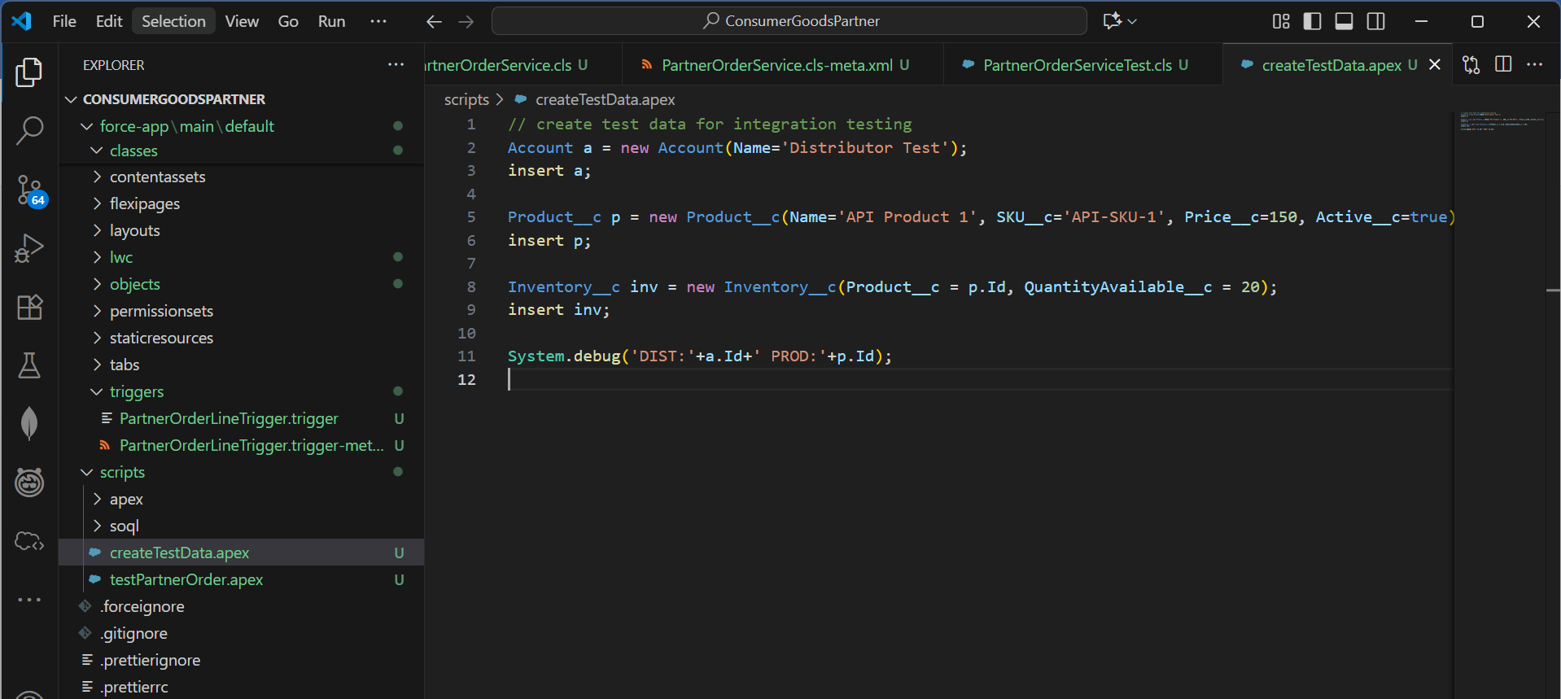

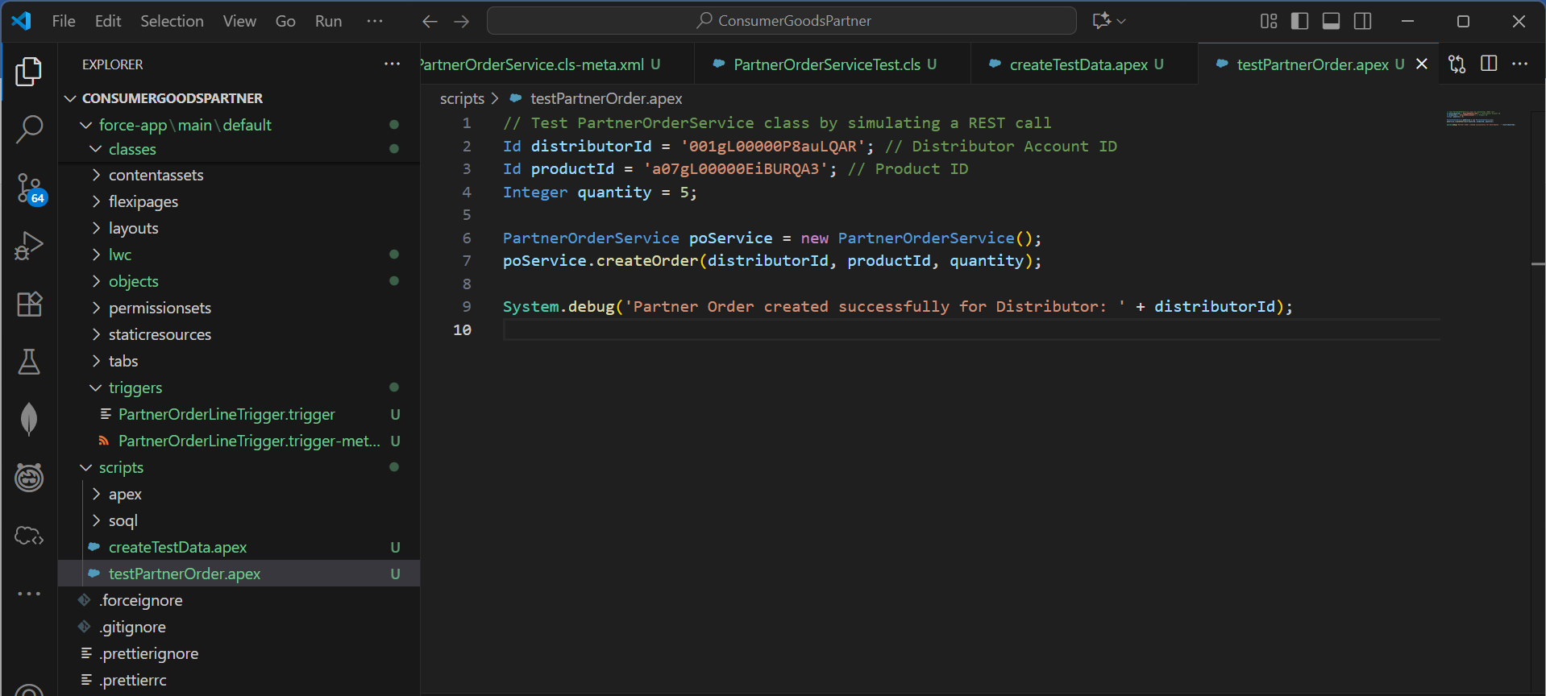

6. Executing Apex in VS Code
- Commands used to run anonymous Apex scripts:
# Execute script file
sf apex run --file scripts/createTestData.apex --target-org DevOrg
- Commands executed successfully created test data with IDs visible in debug logs.

7. Integration Testing
- Tested the PartnerOrderService REST API using Postman with the JSON payload.
- Verified response contains orderId and status code 201.
- Validated that Inventory__c.QuantityAvailable__c was updated correctly after order creation.

8. Exception Handling & Validation
- Apex code includes validation for:
  - Empty or invalid payloads.
  - Missing distributorId or items.
  - Non-existent products.
  - Insufficient inventory.
- Proper HTTP error codes (400) returned for invalid input.

9. Outcome of Phase 5
- Custom Apex classes successfully developed for orders and products.
- Triggers implemented to maintain inventory accuracy.
- Test data scripts created and executed in VS Code.
- REST API endpoints functional and tested with Postman.
- Validations and error handling implemented for robust integration.

Phase 6: User Interface Development

1. Introduction
Phase 6 focuses on building a user-friendly interface in Salesforce using Lightning Experience tools. The objective is to provide business users and external partners with an intuitive interface for interacting with Orders, Products, and Inventory, while integrating Apex and automation seamlessly.
Objectives:
- Create Lightning Pages, Apps, and Tabs for better navigation.
- Develop Lightning Web Components (LWC) to display and interact with Salesforce data.
- Integrate Apex with LWC to perform dynamic operations.
- Optimize page layouts and compact layouts for user convenience.
- Implement navigation, events, and wire services to fetch and display real-time data.

2. Lightning App Builder
Steps Completed:
- Navigated to Setup → App Builder → Lightning App Builder.
- Created a new App Page for Partner Orders:
  - Name: Partner Order Dashboard
  - Template: One Region or Two Regions (for flexibility)
- Dragged standard components: Record Detail, Related Lists, Report Chart.
- Configured Visibility Rules to show components only to specific profiles/roles.
Lightning App Builder → App Page layout → Components visible.
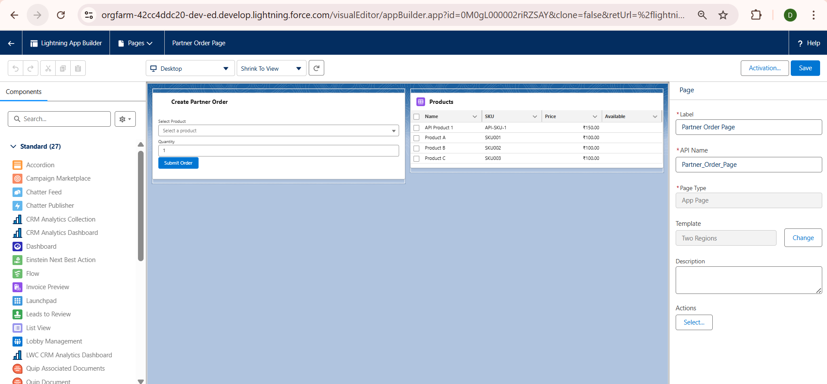

3. Record Pages
Steps Completed:
- Customized Order_Record_Page_Custom for Partner_Order__c:
  - Added Record Detail component to show order info.
  - Added Related Lists component to show Order_Line_Item__c.
  - Embedded a Custom LWC to display real-time inventory availability.
- Activated page as Org Default for the Partner_Order__c object.

4. Tabs & Navigation
Steps Completed:
- Created Custom Tabs:
  - Partner Orders Tab → Linked to Partner_Order__c object.
  - Products Tab → Linked to Product__c object.
- Ensured tabs are accessible in Lightning Apps for users and partners.
- Added tabs to Navigation Bar in Partner Order Dashboard App.
Setup → Tabs → Custom Tabs list with new tabs highlighted.
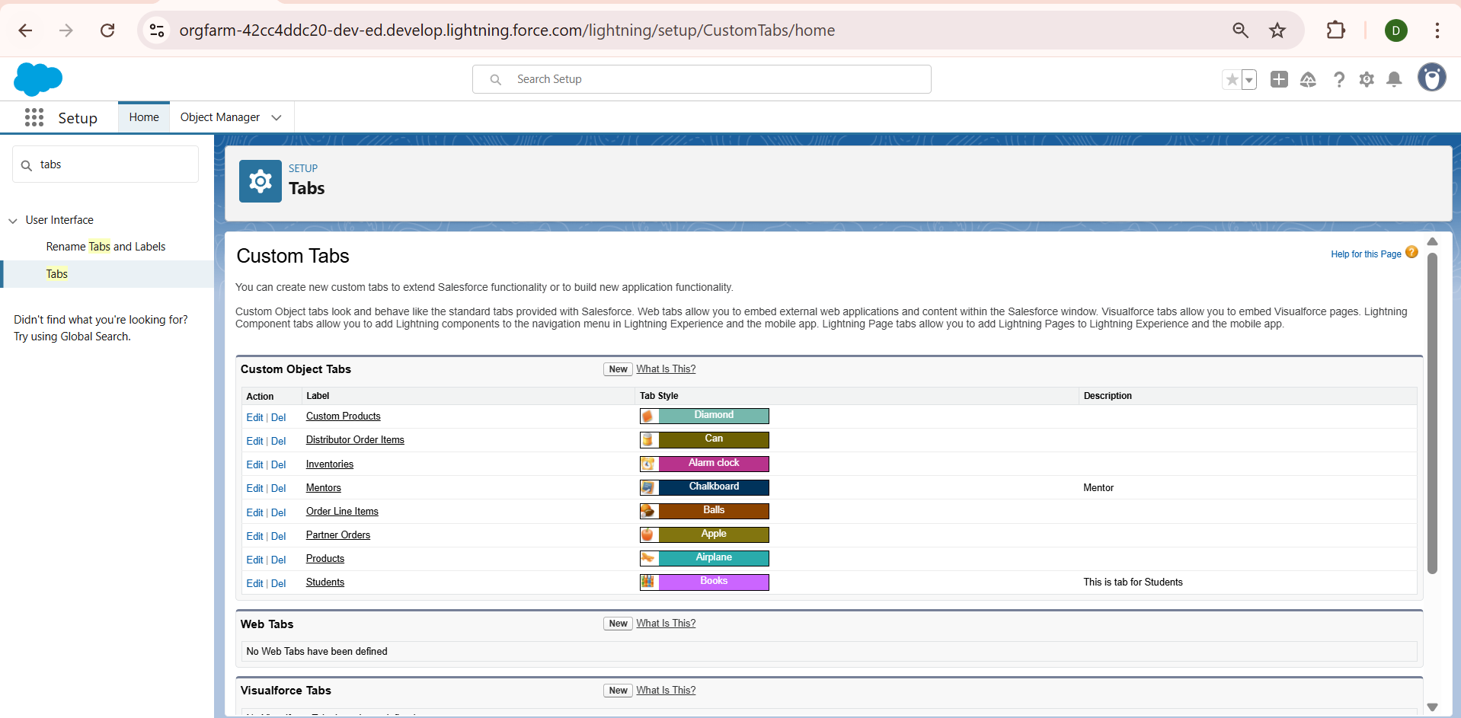

5. Lightning Web Components (LWC)
LWC Development:
- Purpose: Display products, available inventory, and create orders dynamically.
- Integration with Apex:
  - Imperative Apex Calls: Fetch inventory for selected products.
  - Wire Service: Auto-refresh product list when data changes.
  - Events: Send order creation events from child components to parent components.
Example LWC Structure:
partnerOrder
├── partnerOrder.html → Layout of products & inventory
├── partnerOrder.js → Apex calls and events handling
├── partnerOrder.css → Custom styling
└── partnerOrder.js-meta.xml → Metadata for component
Key Features Implemented:
- Real-time product search and selection.
- Quantity input with validation against available inventory.
- Create Order button integrated with PartnerOrderService Apex class.
- Success/Error toast messages after order creation.
VS Code → Explorer → Highlight partnerOrder LWC folder.
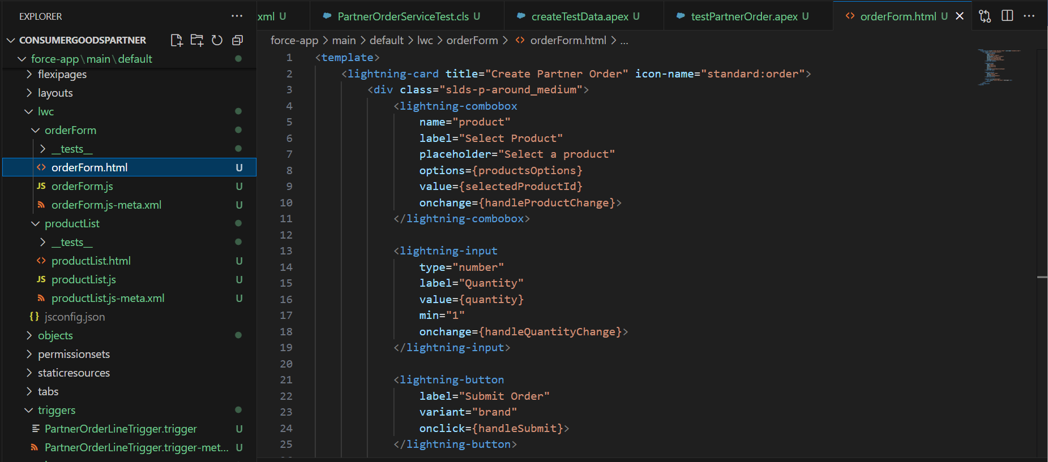
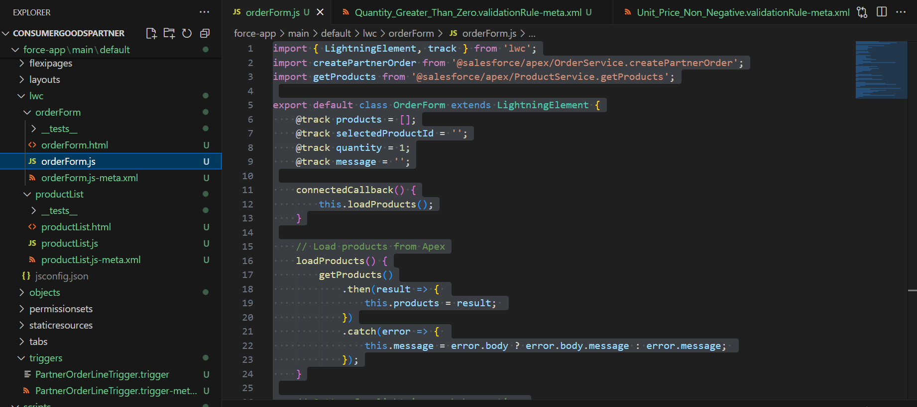

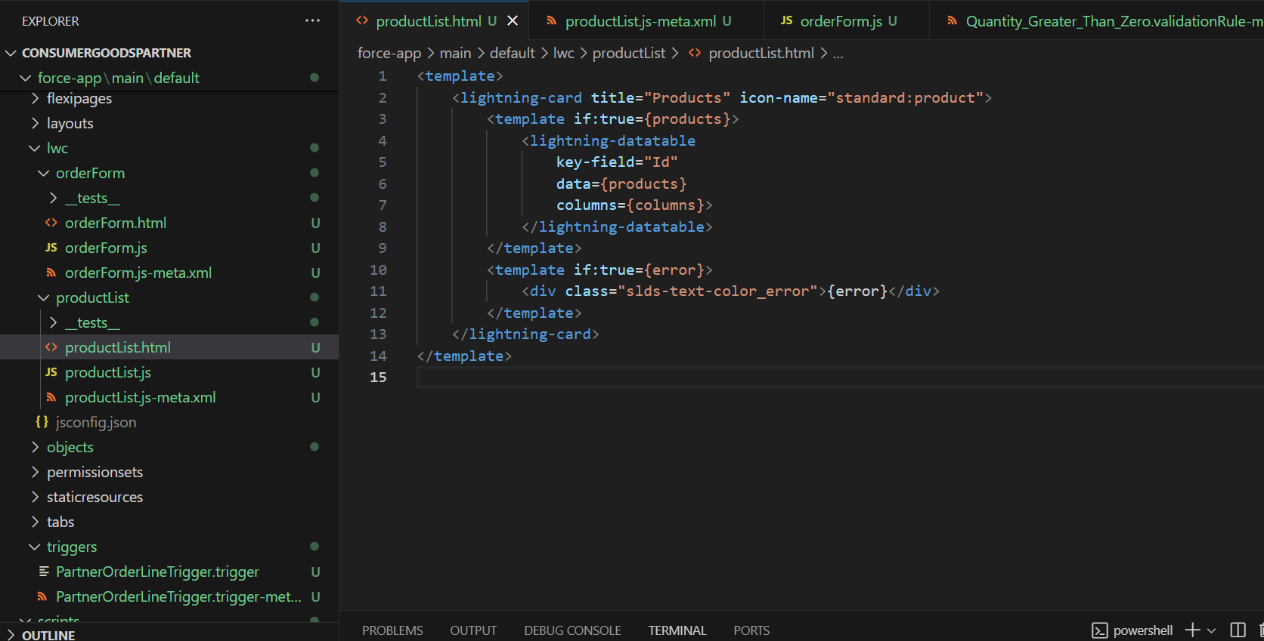

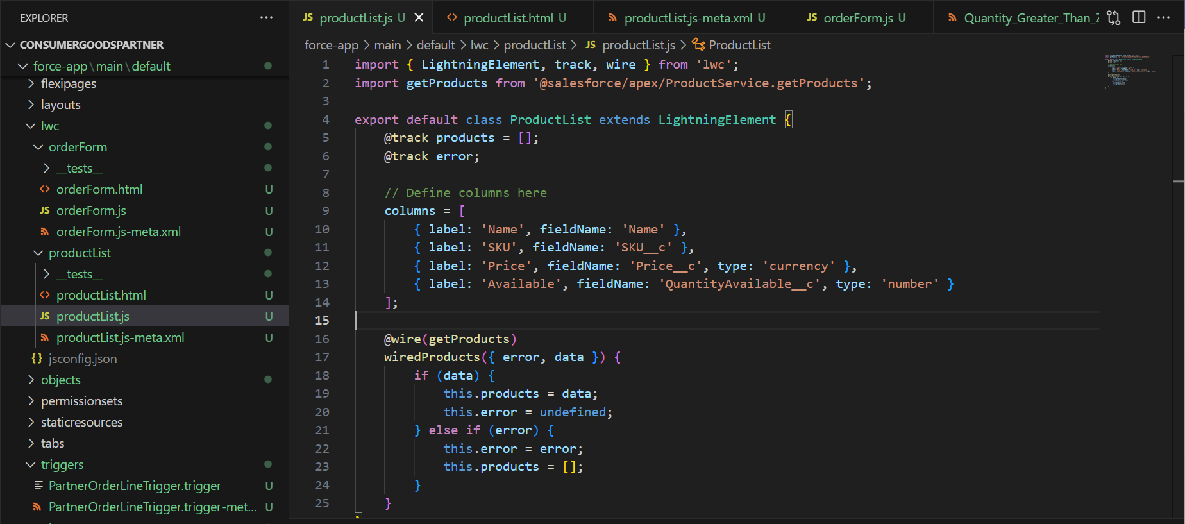

6. Home Page Layouts & Utility Bar
Steps Completed:
- Edited Lightning Home Page to add Partner Dashboard:
  - Components: Recent Orders, Inventory Alerts, Quick Links.
- Configured Utility Bar:
  - Added Quick Create Orders, Search Products, Notifications.
  - Users can access these tools from anywhere in the app.

7. Apex Integration with LWC
- Imperative Apex Example: Fetch Inventory for selected products:
import getInventory from '@salesforce/apex/InventoryController.getInventory';

handleFetchInventory(productId) {
getInventory({ productId: productId })
.then(result => { this.inventory = result; })
.catch(error => { this.error = error; });
}
- Wire Service Example: Auto-fetch products list:
import { LightningElement, wire } from 'lwc';
import getProducts from '@salesforce/apex/ProductService.getProducts';

export default class ProductList extends LightningElement {
@wire(getProducts) products;
}
Screenshot Suggestion: VS Code → LWC JS files → Apex method calls highlighted.

8. Navigation Service
- Implemented NavigationMixin to route users to record pages or apps dynamically.
- Example: Navigate to newly created Partner Order after creation:
import { NavigationMixin } from 'lightning/navigation';

this[NavigationMixin.Navigate]({
type: 'standard__recordPage',
attributes: {
recordId: this.orderId,
objectApiName: 'Partner_Order__c',
actionName: 'view'
}
});

9. Outcome of Phase 6
- Fully customized Lightning pages for orders, products, and dashboards.
- Developed LWC components integrated with Apex for real-time functionality.
- Created custom tabs and home page layouts for smooth navigation.
- Enabled dynamic navigation and event handling in LWCs.
- Users and partners can now interact with data seamlessly, with instant updates reflected in Salesforce.

Phase 7: Integration & External Access

Overview
Phase 7 of the Salesforce project methodology typically involves setting up integrations with external systems, exposing Salesforce data via REST/SOAP APIs, using Named Credentials, handling callouts, working with Platform Events, and implementing advanced authentication mechanisms such as OAuth.
These activities are crucial in enterprise-level implementations where Salesforce needs to act as part of a larger application ecosystem.

Reason for Exclusion in Our Project
After a careful analysis of the project requirements, we decided not to implement Phase 7 because:
- Scope Limitation:
The current project is focused on building a self-contained Salesforce application for managing distributors, products, orders, and reporting. It does not require integration with external ERPs, CRMs, or third-party systems.
- No External System Dependency:
All the business processes (data management, product order processing, reporting, dashboards) were achievable within Salesforce alone, without relying on any outside data sources.
- Simplification of Implementation:
By excluding integrations, we reduced complexity, avoided unnecessary authentication setups, and ensured the project stayed aligned with the intended learning goals of Salesforce Admin + Developer concepts.
- Not Needed for Project Deliverables:
The required functionality (product imports, partner orders, dashboards) could be achieved using standard Salesforce features like Data Import Wizard, Apex classes, Flows, and Reports/Dashboards. Therefore, implementing APIs, callouts, or Named Credentials was not required.

Phase 8: Data Management & Deployment

1. Introduction
Phase 8 focuses on data management, deployment, and version control in Salesforce. The goal is to ensure that data and metadata are consistent across orgs, deployments are successful, and test data is available for integration and functionality testing.
Objectives:
- Deploy Apex classes and metadata to the DevOrg.
- Create test data for integration and REST API testing.
- Understand and use VS Code & Salesforce CLI (SFDX) for deployment and execution.
- Manage data via Data Import Wizard and understand duplicate prevention.

Data Import Wizard – Step-by-Step Implementation
The Data Import Wizard was used in Phase 8 to bulk load product data into Salesforce in a guided, admin-friendly way. This ensured that our Products object was populated with clean, structured data for later use in reports and dashboards.

1. Prepare the CSV File
- Create a CSV file with the following columns:
  - Product Name
  - Product Code (SKU)
  - Price
  - Description
- Save the file as Products_Import.csv.
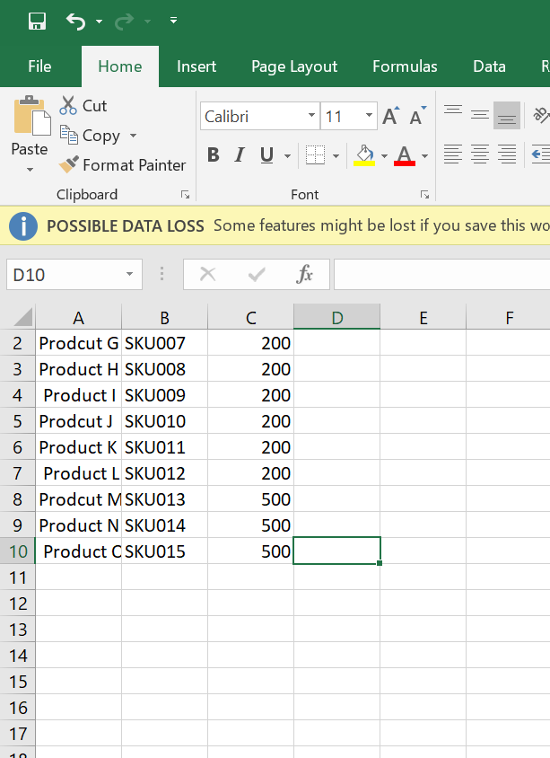

Launch Data Import Wizard
- Go to Setup (gear icon → Setup).
- In the Quick Find box, type Data Import Wizard.
- Click Data Import Wizard from the search results.
- Click Launch Wizard.
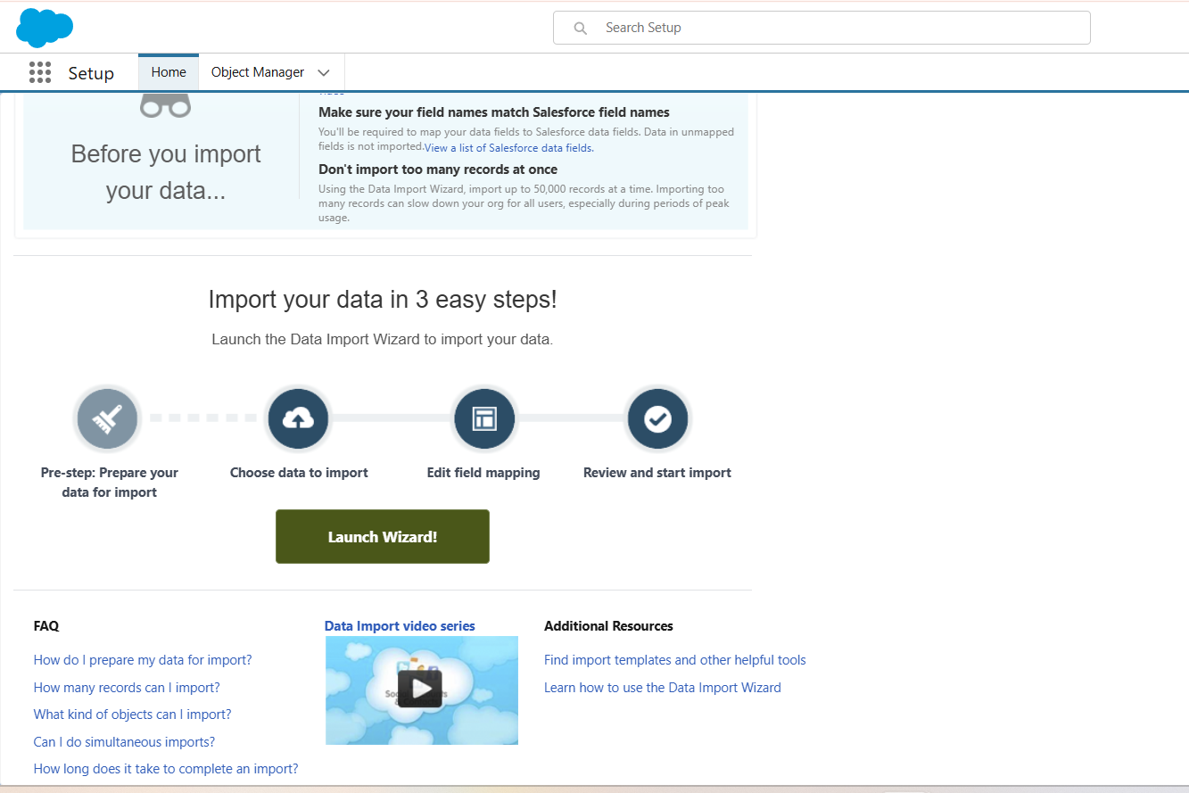

Choose the Object
- Under the Standard Objects or Custom Objects section, select Products (or Product__c if using custom).
- Click Add New Records (since we are inserting products for the first time).
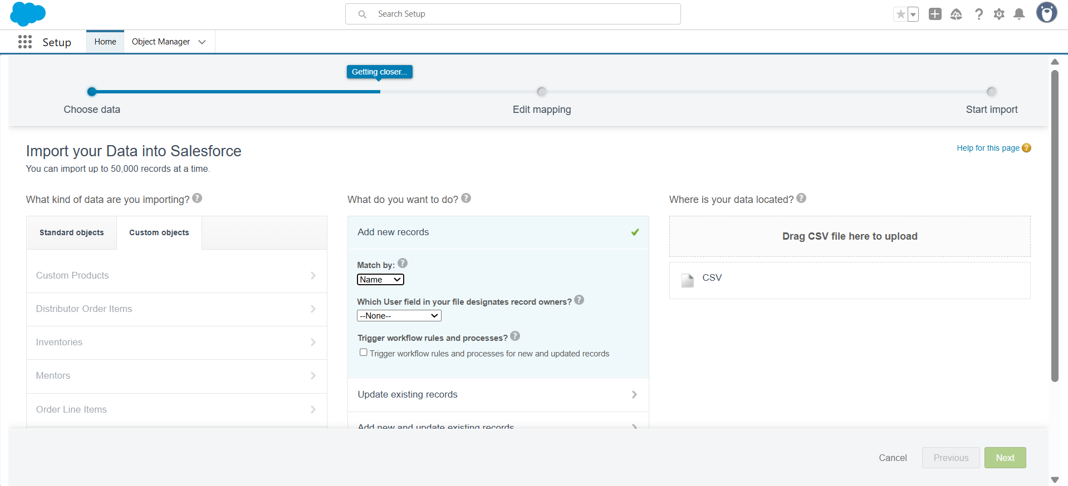

Upload the CSV File
- Click Choose a CSV File → upload Products_Import.csv.
- Click Next.
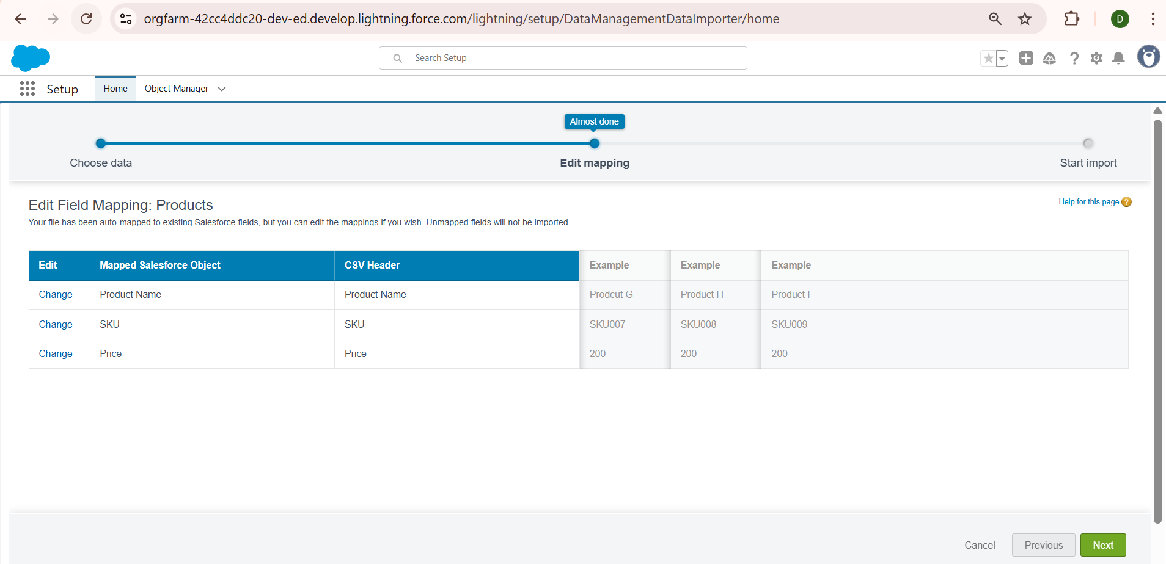

Field Mapping
- The wizard auto-maps most fields; verify mappings:
  - Product Name → Product Name
  - Product Code (SKU) → Product Code
  - Price → Price
  - Description → Description
- If any field is unmapped, manually map it by selecting the correct Salesforce field.
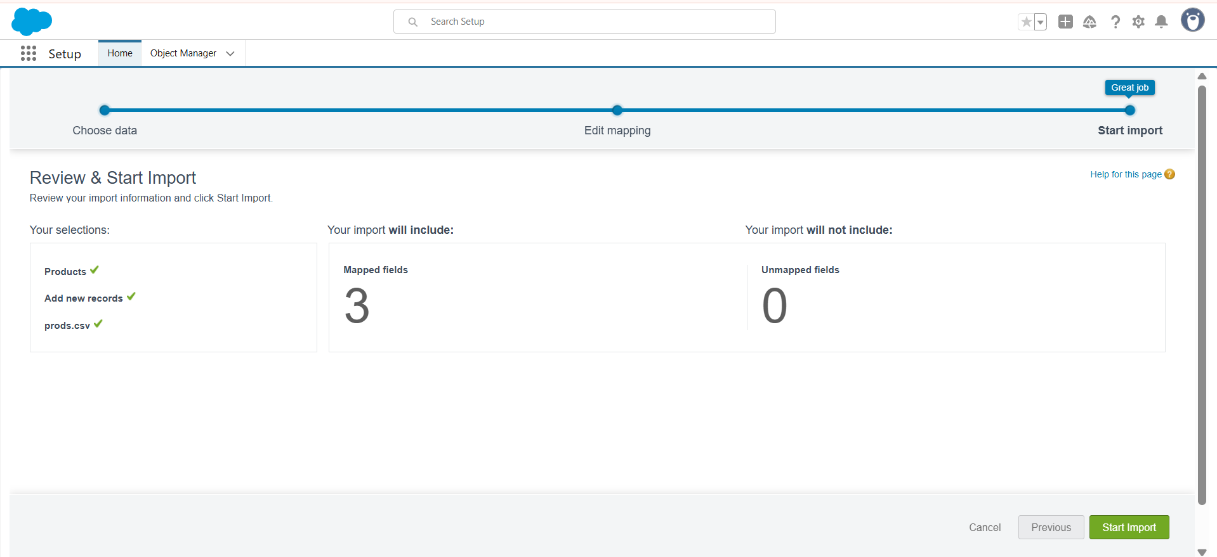

Review and Start Import
- Review the summary of the import.
- Click Start Import.

Monitor Import Progress
- The wizard displays a progress bar for the import.
- Once complete, click View Result.
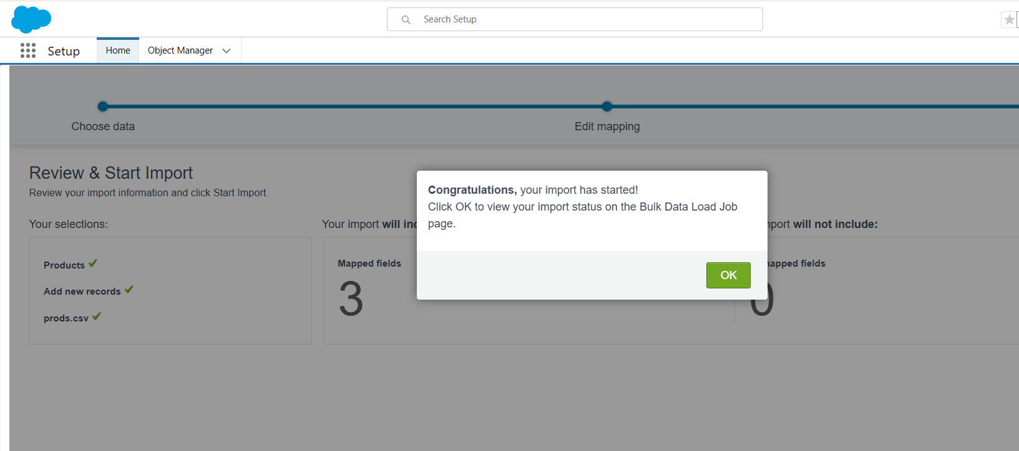

Verify Imported Data
- Navigate to App Launcher → Products.
- Confirm that all product records are created with correct Name, SKU, Price, and Description.
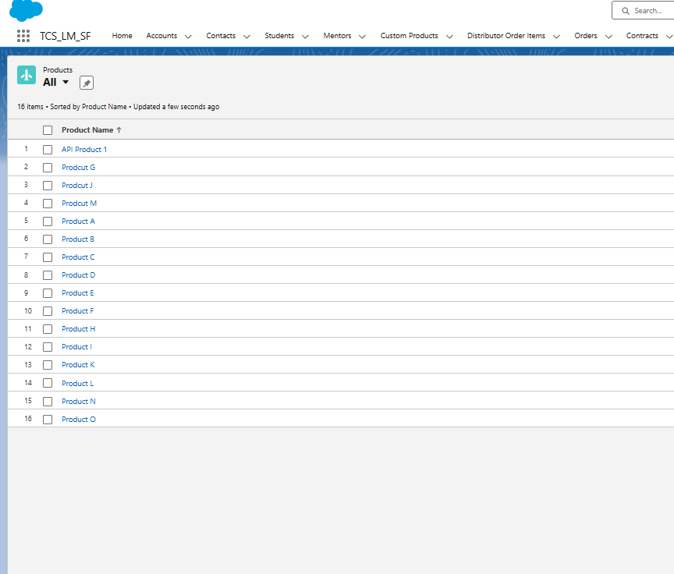

2. Apex Metadata Deployment Using VS Code & SFDX
Steps Completed:
- Opened VS Code in Salesforce project folder.
- Verified connection to DevOrg using sf login org.
- Deployed Apex classes:
sf deploy metadata --metadata ApexClass --target-org DevOrg --wait 10
- Deployment logs showed created and unchanged classes, e.g.:
State | Name | Type
Created | PartnerOrderService | ApexClass
Created | PartnerProductService | ApexClass
Unchanged | OrderService | ApexClass
- Verified deployment success in Setup → Apex Classes in DevOrg.

3. Creating Test Data via Execute Anonymous
Steps Completed:
- Created createTestData.apex script in scripts/ folder:
// create test data for integration testing
Account a = new Account(Name='Distributor Test');
insert a;

Product__c p = new Product__c(Name='API Product 1', SKU__c='API-SKU-1', Price__c=150, Active__c=true);
insert p;

Inventory__c inv = new Inventory__c(Product__c = p.Id, QuantityAvailable__c = 20);
insert inv;

System.debug('DIST:'+a.Id+' PROD:'+p.Id);
- Executed the script using:
sf apex run --target-org DevOrg --file scripts/createTestData.apex
- Confirmed that Accounts, Products, and Inventory records were created in DevOrg.
- Checked debug logs for correct record IDs:
DIST: 001gL00000P8auLQAR
PROD: a07gL00000EiBURQA3

4. Validation of Records
- Queried records to confirm existence:
sf data query --query "SELECT Id, Name FROM Account WHERE Name='Distributor Test'" --target-org DevOrg
sf data query --query "SELECT Id, Name FROM Product__c WHERE Name='API Product 1'" --target-org DevOrg
- Verified IDs match debug logs and can be used for API testing.
Screenshot Suggestions:
- Terminal output showing queried record IDs.

5. Preparing for REST API Testing (Preliminary)
- Used created test data for PartnerOrderService REST API testing.
- JSON payload sample:
{
"distributorId": "001gL00000P8auLQAR",
"items": [
{ "productId": "a07gL00000EiBURQA3", "quantity": 5 }
]
}
- Verified that executing Apex REST service returns 201 Created with newly created Partner Order ID.
Screenshot Suggestions:
- Postman / Workbench showing REST API request and response.
- JSON payload with highlighted IDs.

6. Outcome of Phase 8 (Completed So Far)
- Successfully deployed Apex classes via VS Code & SFDX.
- Created test data for accounts, products, and inventory.
- Queried and verified data in DevOrg.
- Prepared JSON payloads for REST API testing.

Phase 9: Reports and Dashboards

1. Introduction
Phase 9 of our Salesforce Consumer Goods Partner Portal project focused on creating reports and dashboards to provide insights into product data. The goal was to generate a Product Insights Report with detailed product information and a dashboard visualization for business users and partners.
Reports and dashboards allow stakeholders to analyze patterns, track product performance, and make informed decisions quickly.

2. Step-by-Step Implementation

2.1 Creating a Product Report
- Go to App Launcher (9-dot icon) → Select Reports.
- Click New Report.
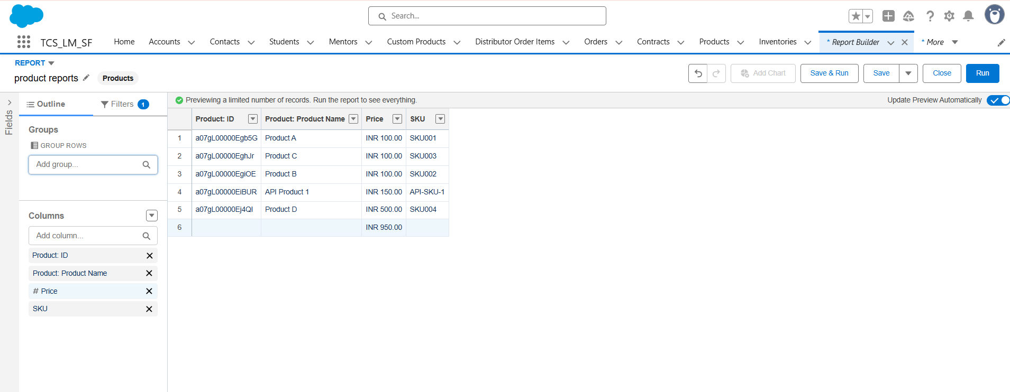
- From the available report types, search for and select Products.
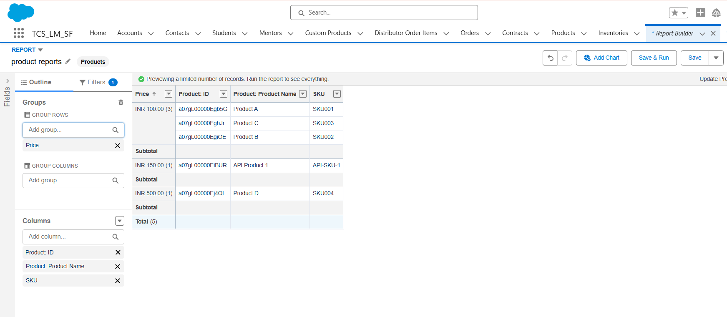
- Click Continue to open the report builder.

- In the Outline panel, add the following fields as columns:
  - Product ID
  - Product Name
  - Price
  - SKU
- In Group Rows, group by:
  - Price
  - SKU
- Save the report:
  - Report Name: Product Insights Report
  - Folder: Public Reports
- Run the report and verify the grouped structure.
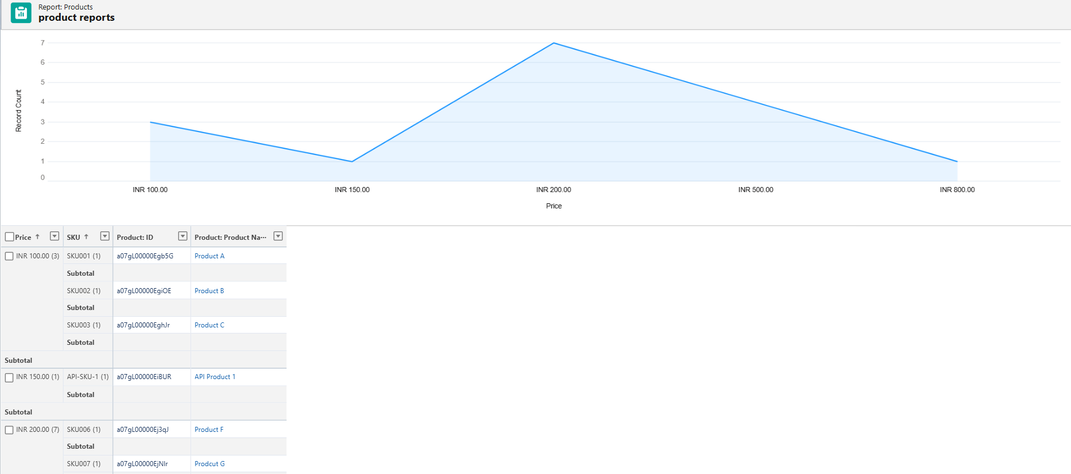

2.2 Creating a Product Dashboard
- Go to App Launcher → Dashboards.

- Click New Dashboard. Enter the details:
  - Dashboard Name: Product Insights Dashboard
  - Folder: Public Dashboards
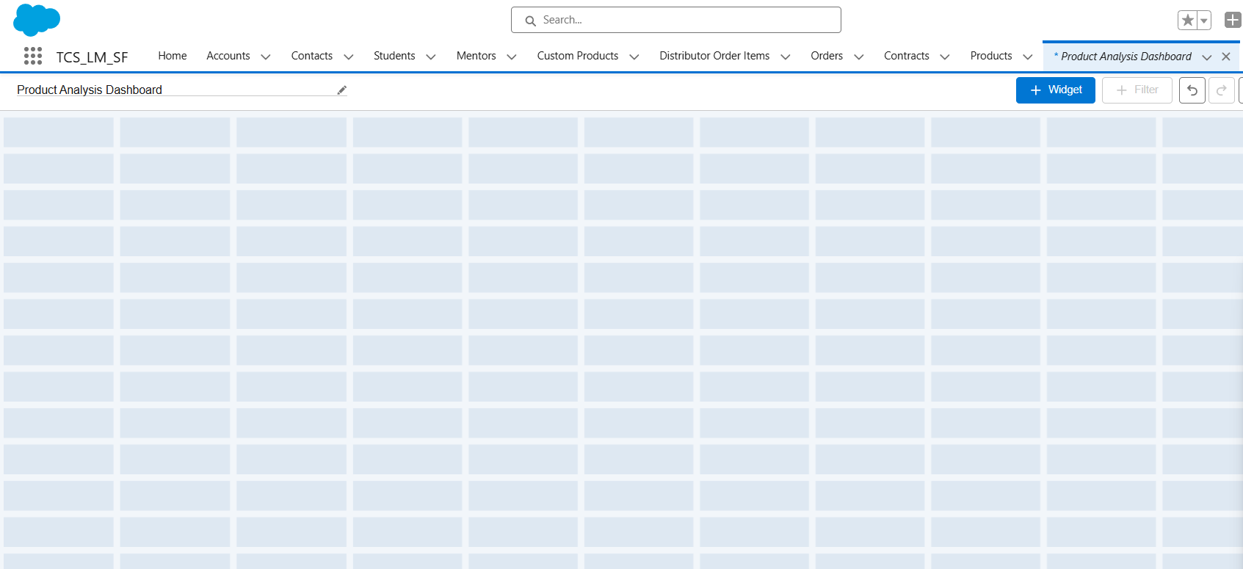
- Once in the Dashboard editor:
  - Click + Component
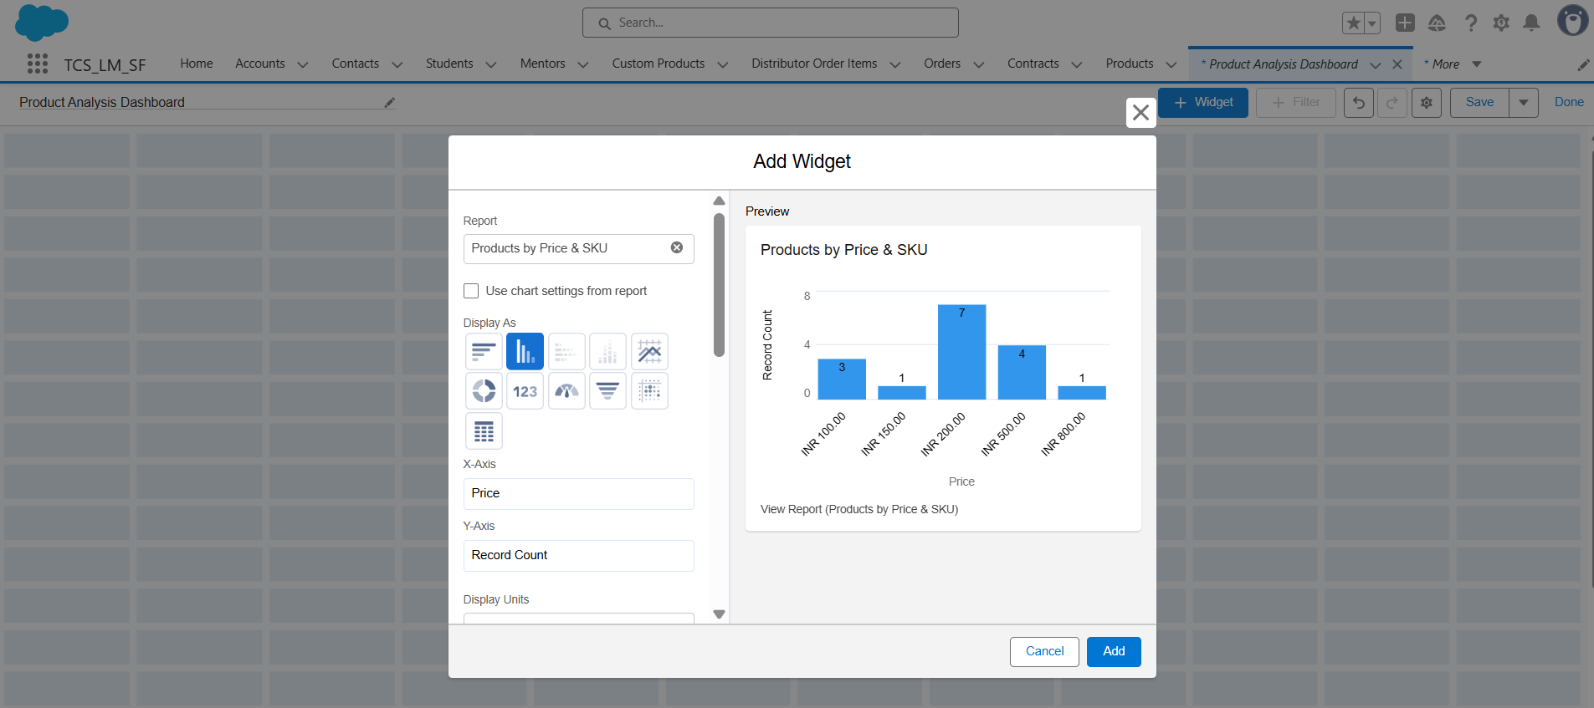
  - Choose the Product Insights Report created earlier

- Select a Bar Chart to compare product prices across SKUs.
- Configure the chart:
  - Title: Product Price by SKU
  - Group by SKU
  - Value: Sum of Price
- Save and refresh the dashboard.
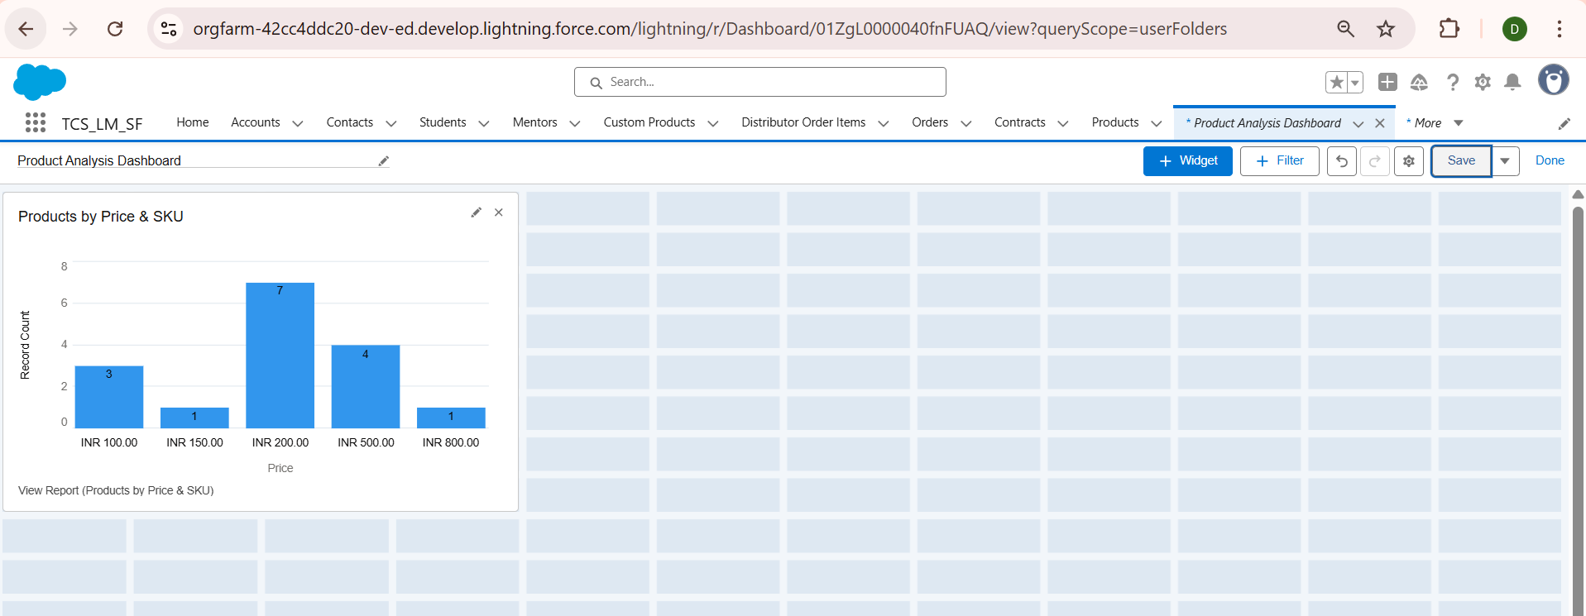

3. Items Not Implemented in Phase 9 (and Reason)
Within Phase 9, certain reporting and dashboard features were not implemented because they were not needed for this project:
- Joined Reports: Not required since analysis was limited to the Products object only.
- Advanced Filters and Cross-Object Reports: Not needed as we only focused on product-level details.
- Multiple Dashboard Tabs/Pages: A single dashboard view was sufficient for the client’s requirement.
- Dynamic Dashboards (per-user views): Not implemented because all users required the same standard product insights view.
By excluding these, we kept the reporting solution simple, relevant, and aligned with project objectives.

4. Outcome
- Successfully created Product Insights Report with Product ID, Name, Price, and SKU.
- Grouped the report by Price and SKU to identify product distribution patterns.
- Built a Product Insights Dashboard that provides a visual overview of product performance.
- Delivered an easy-to-use, centralized reporting tool for decision-making.

